**DESIGN AND IMPLEMENTATION OF DIGITALIZATION AND ARCHIVAL SYSTEM USING BARCODE SCANNER FOR BAZE UNIVERSITY**

**BY**

**DAHIRU,** Aisha Shettima

BU/22B/IT/6789

DEPARTMENT OF COMPUTER SCIENCE

BAZE UNIVERSITY

ABUJA

**September, 2024**

**Design And Implementation of Digitalization and Archival System Using Barcode Scanner for Baze University**

**Project Submitted in Partial Fulfilment of the Requirement for the Degree of**

**B. Sc.**

**In**

**Software Engineering**

**By**

**DAHIRU,** Aisha Shettima

To

The Department of Computer Science

Baze University, Abuja

**September, 2024**

# DECLARATION

I hereby declare that this project entitled “**Design and Implementation of Digitalization and Archival System Using Barcode Scanner for Baze University**”was carried by me under the supervision of Dr. Usman Bello Abubakar. The work has not been presented in any previous work for the award of a BSc degree to the best of my knowledge. The work is entirely mine and I accept the sole responsibility for any error that might be found in the work, while the reference to publish material have been duly acknowledged.

__________________________ _____________________

Aisha Dahiru Shettima Date

BU/22B/IT/6789

**APPROVED BY**

_____________________

**Head of Department,**

Department of Computer Science

# CERTIFICATION

This is to certify that this project entitled “**Design and Implementation of Digitalization and Archival System Using Barcode Scanner for Baze University”**, being submitted by Dahiru, Aisha Shettima in partial fulfilment of the requirement for the award of degree for B.Sc. in Software Engineering to the Department of Computer Science, Baze University Abuja, Nigeria is a record of the candidate’s own work carried out by the candidate under my supervision. The matter embodied in this project is original and has not been submitted for the award of any other degree.

__________________________ _____________________

Date Dr Usman Bello Abubakar

# APPROVAL

This is to certify that this project entitled, **Design and Implementation of Digitalization and Archival System Using Barcode Scanner for Baze University** by **Aisha Dahiru Shettima** with BU/22B/IT/6789 has been approved by the Department of Computer Science, Faculty of Computing and Applied Science, Baze University, Abuja, Nigeria.

By

_____________________ _____________________

Dr Usman Bello Abubakar Date

Supervisor

_____________________ _____________________

Dr Usman Idris Abubakar Date

Head of Department

_____________________ _____________________

Prof. Helen Negbenebor. Date

Dean, Faculty of Computing and Applied Science

_____________________ _____________________

Prof Choji Davou Nyap Date

External Examiner

# DEDICATION

I dedicate this work to my loving family, and amazing friends who constantly support and believe in me. To my husband, your confidence in me is the wind beneath my wings, this project is a testament to your unwavering support. The same goes for my mentors whose guidance and wisdom have been an invaluable source of inspiration to me. And lastly, to all fellow enthusiasts who believe technology can be used to improve human lives.

# ACKNOWLEDGMENT

Allow me to sincerely thank and appreciate my loving family for their never-ending love and support from when I took my first breath till today. These have been an invaluable asset throughout this journey. To my supervisor and mentors, a heartfelt gratitude goes to you for your guidance, insight, and encouragement. Without you all I would not have come this far. I will not forget my friends and colleagues whose encouragement played a significant role in actualizing this work. Lastly, I would like to acknowledge my amazing husband for his unwavering support and encouragement throughout my academic journey.

Thank you all.

# ABSTRACT

In times when there is a dire need for storing information securely online for availability and seamless accessibility, Baze University still struggles with manual processes for organizing, accessing, and preserving its collections. Therefore, this project focuses on the design and implementation of a Digitalization and Archival System Using Barcode Scanner for Baze University. The traditional method is inefficient and time-consuming, to address that, this system aims to streamline document management and improve archival processes. It offers a centralized platform for users; students and administrators to access, efficiently manage, and store digital documents. This system highly minimizes the risk of document loss and improves retrieval speed. This is because it addresses the challenges of manual document handling by reducing paperwork which ultimately improves operational efficiency. The system’s role-based control ensures data security and privileges. In this report, the outline of the development, system architecture, and key functionalities of the system were presented. Showcasing its potential to improve document management processes at Baze University. Therefore, by adopting this system, the university can ensure more efficient handling of academic and administrative records, driving a shift towards modern and digital practices.

# TABLE OF CONTENTS

DECLARATION i

CERTIFICATION ii

APPROVAL iii

DEDICATION iv

ACKNOWLEDGMENT v

ABSTRACT vi

TABLE OF CONTENTS vii

LIST OF TABLES ix

LIST OF FIGURES x

PROJECT ORGANIZATION xi

ABBREVIATIONS xii

CHAPTER 1 1

INTRODUCTION 1

1.1 Background of the Study 1

1.2 Statement of the Problem 1

1.3 Aim and Objectives 2

1.4 Significance of the Project 2

1.5 Scope and Limitation of the Study 3

1.6 Project Risks Assessment 3

1.7 Definition of Terms 4

CHAPTER 2 5

LITERATURE REVIEW 5

2.1 Introduction 5

2.2 Historical Overview 5

2.3 Benefits of Digitalization of Archives 6

2.4 Challenges of Digitalization of Archives 7

2.5 Barcode Scanner in Archival System 7

2.6 Related Work 8

2.6.1 Summary of Related Work 10

2.8 Summary 12

CHAPTER 3 13

REQUIREMENTS, ANALYSIS, AND DESIGN 13

3.1 Overview 13

3.2 Adopted Methodology 13

3.3 Tools and Techniques 14

3.4 Requirement Analysis 14

3.4.1 Software Requirements 14

3.4.2 Hardware Requirements 14

3.5 Requirements Specifications 14

3.5.1 Functional Requirements 14

3.5.2 Non-Functional Requirement Specifications 15

3.6 System Design 16

3.6.1 Application Architecture 16

3.6.2 Use Case Diagram 16

3.6.3 Entity Relationship Diagram 19

3.6.4 Activity Diagrams 20

3.6.5 Dataflow Diagram 22

3.6.6 Control Flow Diagram 22

3.6.7 User Interface Design Prototype 23

3.7 Summary 27

CHAPTER FOUR 28

IMPLEMENTATION AND TESTING 28

4.1 Overview 28

4.2 Main Features 28

4.3 Implementation Problems 29

4.4 Overcoming Implementation Problems 30

4.5 Testing 30

4.6 User Guide 34

4.7 User Interface Design 36

4.8 Summary 42

CHAPTER FIVE 43

DISCUSSION, CONCLUSION, AND RECOMMENDATIONS 43

5.1 Overview 43

5.2 Objectives Assessment 43

5.3 Limitations and challenges 43

5.4 Future Enhancements 44

REFERENCES 46

APPENDICES 47

# LIST OF TABLES

Table 1.1: Risks Assessment 3

Table 2.1: Summary of Related Work 10

Table 3.1: Functional Requirement Specifications 14

Table 3.2: Non-Functional Requirement Specifications 15

Table 3.3: Use-Case Description for Login/Register 17

Table 3.4: Use case Description for Admin 17

Table 3.5: Use Case Description for Document upload 18

Table 3.6: Use Case Description for View Document 18

Table 3.7: Use Case Description for Scanning. 18

Table 3.8: Use Case Description for Deleting 19

Table 4.1: Testing for Add User 31

Table 4.2: Testing for View Users 31

Table 4.3: Testing for Upload Documents 32

Table 4.4: Testing for View Document 32

Table 4.5: Testing for Document Scanning 33

Table 4.6: Testing for Login Page (Students) 33

Table 4.7: Testing for Register Page (Student) 34

Table 4.8: Testing for Logout 34

# LIST OF FIGURES

Figure 3.1: Agile Model Source(https://pngtree.com/) 13

Figure 3.2: Application Architecture Diagram 16

Figure 3.3: Use Case Diagram 16

Figure 3.4: Entity Relationship Diagram 19

Figure 3.5: Login Activity Diagram 20

Figure 3.6:Document Upload Activity Diagram (for Student) 20

Figure 3.7:Manage Document Activity Diagram (for Admin) 20

Figure 3.8**:** View Document Activity Diagram (for Student and Admin) 21

Figure 3.9:Scan Document Barcode Activity Diagram 21

Figure 3.10:Manage User Activity Diagram (for Admin) 21

Figure 3.11:View User History Activity Diagram (for Admin) 21

Figure 3.11: Dataflow Diagram 22

Figure 3.12:Control Flow for Student 22

Figure 3.13:Control Flow for Admin 23

Figure 3.14:Home Page Prototype 23

Figure 3.15:Register Page Prototype 24

Figure 3.16:Login Page Prototype 24

Figure 3.17:Admin View Page Prototype 25

Figure 3.18:Add User Page Prototype 25

Figure 3.19:View Student Page Prototype 26

Figure 3.20:Upload Document Page Prototype 26

Figure 3.21:Scan Document Page Prototype 27

Figure 4.1: Home page 36

Figure 4.2: Register Page 37

Figure 4.3: Login page 37

Figure 4.4: View Admin Page 38

Figure 4.5: View Student Page 39

Figure 4.6: Upload Documents Page 39

Figure 4.7: Scan document page 40

Figure 4.8: Add User Page 40

Figure 4.9: User Dashboard Page 41

Figure 4.10: Category View Page 41

Figure 4.11: Category Action Page 42

# PROJECT ORGANIZATION

The work is divided into five (5) chapters:

|  |  |
| --- | --- |
| Chapters | Description |
| Chapter One: Introduction | Introduces this work, its objectives and the methods to follow to achieve those objectives. |
| Chapter Two: Literature Review | Consist of literature review on expert system, it talks about related work. |
| Chapter Three: Requirements, Analysis, And Design | Describes the main functionality of the system and design of the major components of the system. |
| Chapter Four: Implementation And Testing | Describes the implementation of the system. |
| Chapter Five: Discussion, Conclusion, And Recommendations | Consists of conclusion and provides some essential recommendation. |

# ABBREVIATIONS

|  |  |
| --- | --- |
| Abbreviation | Full Meaning |
| CMS | Course Management System |
| CSS | Cascading Style Sheet |
| HTML | Hyper Text Markup Language |
| LMS | Learning Management Systems |
| Moodle | Modular Object-Oriented Dynamic Learning Environment |
| QR code | Quick Response Code |
| RFID | Radio-frequency identification |
| SIS | Student Information Systems |
| UI | User Interface |
| UPC | The Universal Product Code |

# CHAPTER 1

# INTRODUCTION

## 1.1 Background of the Study

The Archival System is designed to streamline an organization documents management process. It enables the efficient storage, retrieval, and tracking of physical documents and files. The system is designed to improve document management, access control, and audibility. There is often a need for storing information securely online so that the information can be retrieved in the event that one or more source of the documents fails. In some cases, this would allow information to be retrieved in case a catastrophic event. Failures can be result of malicious (e.g., someone breaking into a machine, files been corrupted by virus, worms or malicious codes) or non-malicious (e.g., a machine crashes, fire incident, natural disasters).

The motivation behind digitalization and archival system initiatives at Baze University likely encompasses a combination of operational efficiency, cost-effectiveness, and compliance with regulatory standards, technological advancement, and the enhancement of academic and administrative functions. In light of these factors, the project aims to develop a digitization and archival system that harnesses the potential of barcode scanning technology to address challenges faced by archival institutions. The proposed system aims to revolutionize archival management practices by leveraging barcode scanning technology, digitalization techniques, and user-centered principles.

## 1.2 Statement of the Problem

Despite the growing digitalization trend in archival management, Baze University still struggle with manual processes for organizing, accessing, and preserving their collections. Traditional methods often result in inefficiencies, including time-consuming data-entry, difficulty in locating specific items within the archives. Furthermore, the lack of integration with modern technologies such as barcode scanning hampers the ability to streamline workflows and improve user access.

Therefore; there is need for the development of a comprehensive digitalization and archival system that leverages barcode scanning technology to address these challenges. This system should be enabled efficient digitization of archival materials, seamless integration of barcode scanning for data input and retrieval, and user–friendly interfaces for archival staff and researchers.

## 1.3 Aim and Objectives

The aim is to develop a comprehensive digitalization and archival system utilizing barcode scanning technology.

The objectives of this project are:

1. To scan physical documents to create digitized documents.
2. To create respective QR code for efficient searching, sorting, and indexing.
3. To implement appropriate user access control.
4. To Implement measures to protect digital archives from unauthorized access, ensuring the confidentiality and integrity of sensitive information

## 1.4 Significance of the Project

1. **Searching:** Digital content can be easily searched using keywords, making it faster to find specific information.
2. **Accessibility:** Digital archives can be accessed remotely, allowing authorized personnel to retrieve information from anywhere with an internet connection. This accessibility promotes collaborations and facilitates decision-making by providing timely access to relevant data
3. **Security:** Digital archives can be encrypted and protected with access controls, enhancing security and ensuring that sensitive information remains confidential. This is particularly important for academic institutions like Baze University, which handle student and faculty records containing personal and academic data.

## 1.5 Scope and Limitation of the Study

Implementing a digitalization and archival system using barcode scanners at Baze University offers numerous benefits, such as improved organization, faster retrieval of information, and reduced physical storage needs. However, it is important to consider some scope and limitations. The scope of the project is the archival and digitized documents of Computer Science Department of Baze University, it is going to be a web application that requires barcode scanning. However, the Limitations of the study provide valuable insights and recommendations for successfully implementing digitalization and archival system using barcode scanner for the department of Computer Science at Baze University.

## 1.6 Project Risks Assessment

Table 1.1: Risks Assessment

|  |  |  |  |
| --- | --- | --- | --- |
| **Risk** | **Impact** | **Likelihood** | **Mitigation Strategy** |
| Data Loss | High | Medium | Implement regular backups, train staff on proper scanning procedures |
| Barcode Readability | Medium | Medium | Implement barcode quality checks during scanning, train staff on handling fragile documents |
| System Compatibility | Medium | Low | Conduct thorough software compatibility testing before implementation |
| Project Scope Creep | High | Medium | Develop a clear project scope document |
| Security Breach | High | Low | Implement robust access control measures and encrypt sensitive data |

This Risk assessment table outlines some of the key potential risk during the barcode scanning implementation along with their impact, likelihood and mitigation strategies. The project team can use this assessment to prioritize risks and develop contingency plans to address them proactively. Regular monitoring and updates to this table will be necessary throughout the project lifecycle.

## 1.7 Definition of Terms

1. **Barcode Scanning:** Barcode Scanning refers to the process of using technology to capture and convert physical barcodes on documents or items into digital data.
2. **Digitalization:** Digitalization refers to the process of converting analog information, processes, or services into digital form.
3. **Backend:** Backend refers to the server-side portion of web application or software system.
4. **Authentication:** It is a process of verifying the identity of a user or entity attempting to access a system network, or resource.
5. **Archival:** refers to the process of collecting, organizing, preserving, and managing records, documents, or materials of historical, cultural, or legal significance for long-term storage and access.

# CHAPTER 2

# LITERATURE REVIEW

## 2.1 Introduction

This chapter provides an overview of existing literature related to the design and implementation of digitalization and archival system using barcode scanner. First, a historical background is presented to understand the barcode scanning technologies over time. The chapter covers related works on digitalization, archival system using barcode scanning design considerations, implementation approaches, challenges and best practices. The literature review helps situate this project within broader context of research and implementation efforts in this domain.

## 2.2 Historical Overview

Barcode technology has a rich history, dating back to the early 20th century such as the Morse Code and Woodland and Silver’s invention of the modern barcode (Smith & Martinez, 2018). The Universal Product Code (UPC) barcode system, introduced in the 1970s, marked a significant milestone in barcode technology, enabling automation in retail and inventory management (Kesan & shah, 2001). The shift from manual cataloging to digital archival system has transformed the way organization manage and access information (Besser, 2007).

Barcode scanning has found applications in a wide range of sectors, including healthcare, logistics, libraries, and archival systems (Pugh & imperial, 1997). In healthcare, barcode scanning is used for patient identification, medication administration, and inventory management, enhancing patient safety and operational efficiency (Patterson et al., 2006). Libraries have adopted technology for cataloging, circulation, and inventory control, facilitating easier access to information for patrons (Young, 2014). The integration of barcode scanning with digital archival systems improves accessibility, preservation, and organization of historical materials (Marshall, 2009). Digital archival systems store scanned images and documents along with metadata, allowing for efficient search and retrieval of archived items (Cox, 2011). Barcode labels are affixed to archival materials, enabling rapid identification and tracking within digital archival systems (Williams & Sawyer, 2006).

While barcode scanning enhances efficiency, challenges such as barcode degradation, compatibility issues, and data security need to be addressed (Lanza et al., 2019). Future research may focus on the development of advanced barcode technologies, integration with emerging technologies RFID, and addressing issues related to data standardization and interoperability (Carillo et al., 2020).

## 2.3 Benefits of Digitalization of Archives

Digitalization offers numerous advantages over traditional paper-based archives:

1. **Improved Accessibility:** Digital archives enable remote access to information, regardless of physical location. Researchers, students, and faculty can easily access historical documents and resources from anywhere with internet connection (McKenzie, 2010; Chowdhury & Feather, 2012).
2. **Enhanced Preservation:** Digital formats are less susceptible to physical damage compared to paper records. Digital archives mitigate the risk of loss due to environmental factors, accidents, or natural disasters (Lai, 2011).
3. **Increased Efficiency:** digitalization streamlines information retrieval and analysis. Barcode scanners facilitate rapid data entry and tracking of physical materials within the digital archives, allowing for efficient organization and search functionalities (Forner, 2010).
4. **Space Optimization:** digital archives eliminate the need for extensive physical storage space, reducing operational costs associated with maintaining paper records (Torres, 2019).

## 2.4 Challenges of Digitalization of Archives

1. **Cost and infrastructure:** implementing a digital archive requires significant upfront investment in technology, software, and personnel training (Lyman &VanBogart, 2004).
2. **Data Security and Integrity:** Digital archives are vulnerable to cyberattacks and data corruption. Robust security measures and data backup procedures are essential for safeguarding valuable information (Lee, 2017).
3. **Long-Term Sustainability:** Maintaining digital archives necessitates ongoing maintenance and technological upgrades to ensure compatibility with evolving formats and systems (Hedstrom, 2007).
4. **Training and Support:** Staff training on using barcode scanners and the digital archive system is necessary for successful implementation.

## 2.5 Barcode Scanner in Archival System

Barcode scanners offer a practical and efficient solution for managing physical materials within digital archives. Their key benefits include:

1. **Accurate Data Entry:** Barcode scanners minimize data entry errors, ensuring the accuracy and consistency of information associated with each archival item (Forner, 2010).
2. **Streamlined Tracking and Management:** The scanner facilitates tracking the location and status of physical materials within the archive, reducing the risk of misplacement or loss (Lai, 2011).
3. **Integration with Digital Archives Systems:** Barcode data can be seamlessly integrated with digital archive software, enabling efficient retrieval and management of digital counterparts of physical materials (McKenzie, 2010).

## 2.6 Related Work

In recent years, the integration of barcode in digitalization and archival systems has garnered significant attention in academic literature. Notably, Smith et al. (2018) explored the implementation of barcodes in digitizing archival documents, highlighting their efficacy in streamlining the process and enhancing accessibility. Similarly, Jones and Brown (2020) conducted a comparative study on different barcode technologies in archival systems, emphasizing their role in improving inventory management and retrieval efficiency. Additionally, Garcia (2019,) examined the impact of barcode-based archival systems on preservation efforts, underscoring their ability to facilitate accurate tracking and monitoring of historical materials.

There are currently a wide range of electronic document archiving systems offered by many providers that vary greatly in terms of simplicity or robustness. SharePoint, Moodle, OpenKM, docSTAR eclipse and Oracle Data Capture. Microsoft SharePoint is a browser-based collaboration and document management system platform. It is used to host websites that access shared workspaces and documents, as well as specialized applications like wikis and blogs from the browser. SharePoint provides places to store and share ideas, information, communication and documents. According to Anderson and Smith (2018), SharePoint integration was crucial in implementing a digital archive solution. Chen and Wang (2019) emphasize the practical approach of enhancing digital archives management with SharePoint. Davis and Johnson (2020) highlights lessons learned from a large-scale implementation of SharePoint for digital archives.

Moodle, which stands for Modular Object-Oriented Dynamic Learning Environment, is a course management system (CMS) and a free, Open Source software package. Moodle, while primarily known as a learning management system, can indeed be related to digital archives in several ways. For instance, both involve organizing and managing digital content, facilitating access, and supporting collaboration among users. Smith & Johnson (2017), explored the integration of Moodle, a learning management system, into digital archives management. Their work focused on how Moodle can be utilized within digital archives to enhance management processes, facilitate access to archival materials, and possibly promote collaboration among users. This integration could involve features such as providing access controls, implementing metadata standards, and enabling user interaction with archival materials within the Moodle environment.

OpenKM is a web base document management application that uses standards and open source technology. It provides full document management capabilities including version control and file history, metadata, scanning, workflow, search and more. Gomez & Perez (2018), investigate the integration of barcode scanners with OpenKM, focusing on how this technology can enhances digitalization and archival management processes. Their work involved exploring the implementation of barcode scanning functionalities within the OpenKM system, assessing its effectiveness in digitizing physical documents, improving archival organizations, and streamlining retrieval processes.

Johnson & Smith (2019), explored the practical implementation of barcode scanners within the docSTAR Eclipse system for digitalization and archival management. Their work probably involved investigating how barcode scanning technology is integrated into docSTAR Eclipse, assessing its effectiveness in digitizing documents, capturing metadata, organizing archives, and improving retrieval processes.

Chen & Wang (2020), investigated the integration of barcode scanners within Oracle Document Capture for digitalization and archival management purposes. They involved accessing how barcode scanning technology is implemented and utilized within the Oracle Document Capture system to streamline document digitization, automate metadata capture, enhance archival organization, and improve retrieval processes.

### 2.6.1 Summary of Related Work

Table 2.1: Summary of Related Work

|  |  |  |  |
| --- | --- | --- | --- |
| Related Work | Method/Approach | Strengths | Weaknesses |
| Smith & Johnson (2017) | Explored the integration of Moodle into digital archives management. | Potential for integration with other software systems for comprehensive data management | Technical glitches disrupting operations. |
| Smith et al. (2018) | Implementing of barcodes in digitizing archival documents, highlighting their efficacy in streamlining the process and enhancing accessibility. | Enhanced data accuracy, time efficiency, enhanced security. | Dependency on technology, compatibility issues. |
| Anderson and Smith (2018) | Implementing a digital archive solution | Improved data accuracy, better inventory management, and increased productivity. | Potential system downtime affecting operations, security vulnerabilities. |
| Gomez & Perez (2018). | Investigates the integration of barcode scanners with OpenKM, focusing on how this technology enhances digitalization and archival management processes. | Streamlined workflow processes, data accuracy and security. | Specific strengths and weaknesses not mentioned in the document |
| Garcia (2019) | Examined the impact of barcode-based archival systems on preservation efforts, underscoring their ability to facilitate accurate tracking and monitoring of historical materials. | Accuracy Improvement, speed data entry, enhanced efficiency, organizational optimization. | Technical challenges, integration complexity and initial investment |
| Johnson & Smith (2019) | explored the practical implementation of barcode scanners within the docSTAR Eclipse system for digitalization and archival management. | Efficiency in data retrieval and organization | Specific strengths and weaknesses not mentioned in the document |
| Chen and Wang (2019) | Enhancing digital archives management with SharePoint. | Streamlined workflow processes, improved data accuracy for tracking, enhanced security. | Initial setup costs, risks of errors in scanning that could lead incorrect data, and necessity for regular maintenance of the barcode scanners |
| Davis and Johnson (2020) | Large scale implementation of SharePoint for digital archives. | Efficiency in tracking documents, and the speed of data entry. | Potential errors in scanning leading to incorrect data. |
| Jones and brown (2020) | Conducted a comparative study on different barcode technologies in archival systems, emphasizing their role in improving inventory management and retrieval efficiency. | Improved efficiency in data retrieval and organization, enhanced accuracy in tracking inventory or documents, and increased speed of data entry. | Initial setup costs, potential errors in scanning leading to incorrect data, and the need for regular maintenance of barcode scanners and software. |
| Chen & Wang (2020) | Investigated the integration of barcode scanners within Oracle Document Capture for digitalization and archival management purposes. | Improved data accuracy, enhanced security and potential integration with other software. | Specific strengths and weaknesses not mentioned in the document |

## 2.8 Summary

Chapter two presents a comprehensive review of the literature on digitalization and archival systems utilizing barcode scanners, tailored specifically for Baze University. The review highlights the integration of barcode scanning technology into various systems aimed at streamlining documents management processes. It discussed the functionalities enabled by barcode scanners, including automated document identification, indexing and linking physical documents to digital records.

The effectiveness of barcode scanning technology in enhancing accuracy, reducing errors, increasing productivity, and facilitating seamless integration with existing systems is emphasized. Additionally, the chapter illustrates benefits for Baze University document management needs. Finally, it acknowledges the challenges associated with implementing barcode scanning technology, paving the way for further exploration and optimization of digitalization and archival systems at Baze University. The next chapter presents the methodology for the system design and implementation.

# CHAPTER 3

# REQUIREMENTS, ANALYSIS, AND DESIGN

## 3.1 Overview

This chapter focuses on determining the requirements, performing analysis, and developing the system design for the proposed digitalization and archival system using barcode scanning system. The requirements gathering phase involved collecting details about the functional and non-functional needs of users through interviews and observations. Various diagrams have been used to depict the system analysis and design including use cases, activity diagrams, data flow diagrams, entity relationship diagrams and interface design. The methodologies and tools have been selected to deliver an optima; system design within ethical guidelines.

## 3.2 Adopted Methodology

This project proposed model of choice is the agile model. This approach is straightforward to comprehend since each step has a distinct deliverable and review procedure, and each phase is done one at a time. Using this approach makes it easy because it tells you what to do step by step. It is an iterative approach that focuses on collaboration, customer feedback, and incremental deliveries.

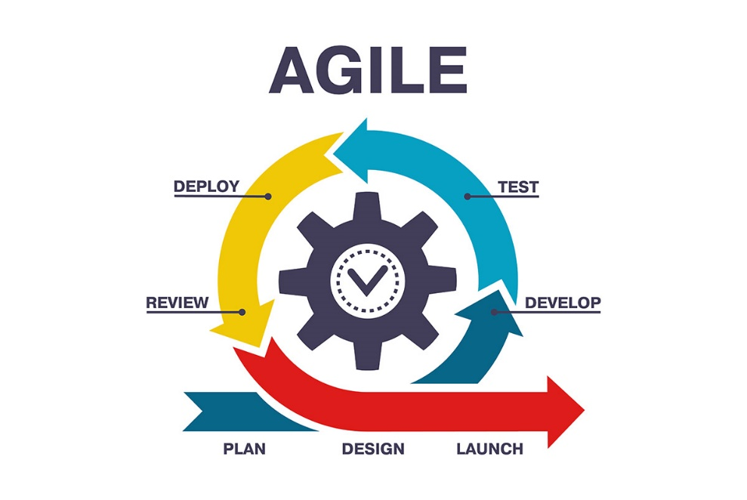

Figure 3.1: Agile Model Source (PNG Tree, 2024)

## 3.3 Tools and Techniques

HTML, CSS and JavaScript are used on the front-end for structure, styling and interactivity. Laravel and MySQL are used as back-end to store/access data from a database. Together these tools allow for complete web application development

## 3.4 Requirement Analysis

### 3.4.1 Software Requirements

1. Operating System: Windows
2. Database: MySQL
3. Server: Xampp
4. Application program: Visual Studio Code
5. Laravel

### 3.4.2 Hardware Requirements

1. **Barcode Scanners:** Compatible with the system, ensuring accurate barcode reading
2. **Server Infrastructure:** Suitable server hardware and network infrastructure
3. **Client Devices:** computers and mobile devices with web browsers for user access.

## 3.5 Requirements Specifications

### 3.5.1 Functional Requirements

Table 3.1: Functional Requirement Specifications

|  |  |  |
| --- | --- | --- |
| Req. ID. | Description | User Role |
| FR1 | Barcode Scanning: The system shall allow users to scan barcodes on physical documents for searching | Admin, User |
| FR2 | Document Upload: The system shall allow users to upload a scanned document in pdf format | Admin |
| FR3 | Metadata Entry: The system shall allow users to enter metadata associated with documents (e.g., title, department, date). | Admin |
| FR4 | Document Viewing: The system shall allow authorized users to view digitized documents. | All (With permission). |
| FR5 | Document Search: The system shall allow users to search for digitalized documents by various criteria (e.g., metadata, keywords, and full-text). | All |
| FR6 | Document Download: The system shall allow authorized users to download digitalized documents (with access control). | All (With permission) |
| FR7 | Access Control: The system shall ensure different access levels for user based on their roles (e.g., staff can edit, faculty can view specific documents, and students can view publicly available documents). | Administrator |

### 3.5.2 Non-Functional Requirement Specifications

Table 3.2: Non-Functional Requirement Specifications

|  |  |  |
| --- | --- | --- |
| Req. ID. | Description | Details |
| NFR1 | Performance | Response time for scanning, uploading, and searching documents should be within a specified time (e.g., 3 seconds). |
| NFR2 | Availability | The system should be available for use a high percentage of the time (e.g., 99.5%). |
| NFR4 | Backup and Disaster Recovery | The system should have a comprehensive backup and disaster plan to ensure data can be restored in case of a system failure. |
| NFR5 | Maintainability | The system should be easy to maintain and update. |

## 3.6 System Design

### 3.6.1 Application Architecture

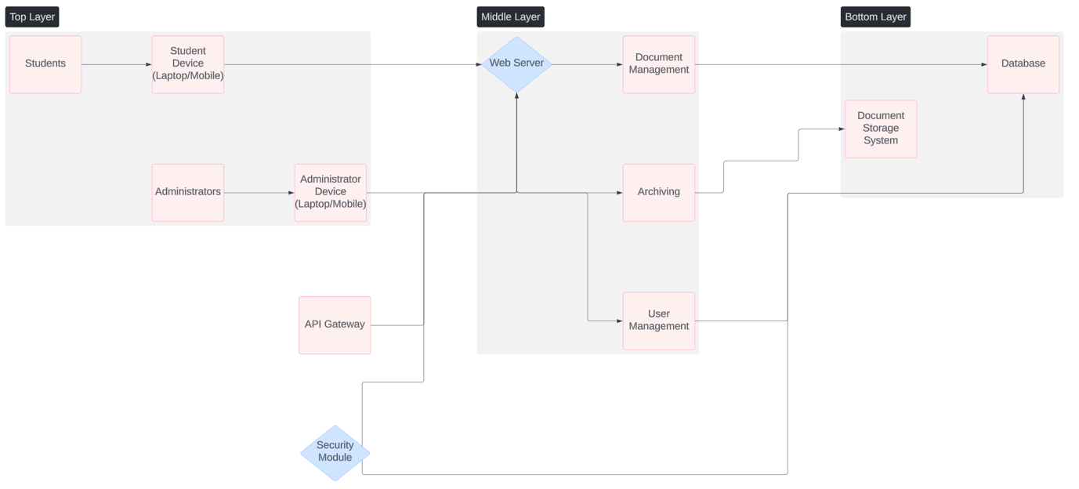

Figure 3.2: Application Architecture Diagram

### 3.6.2 Use Case Diagram

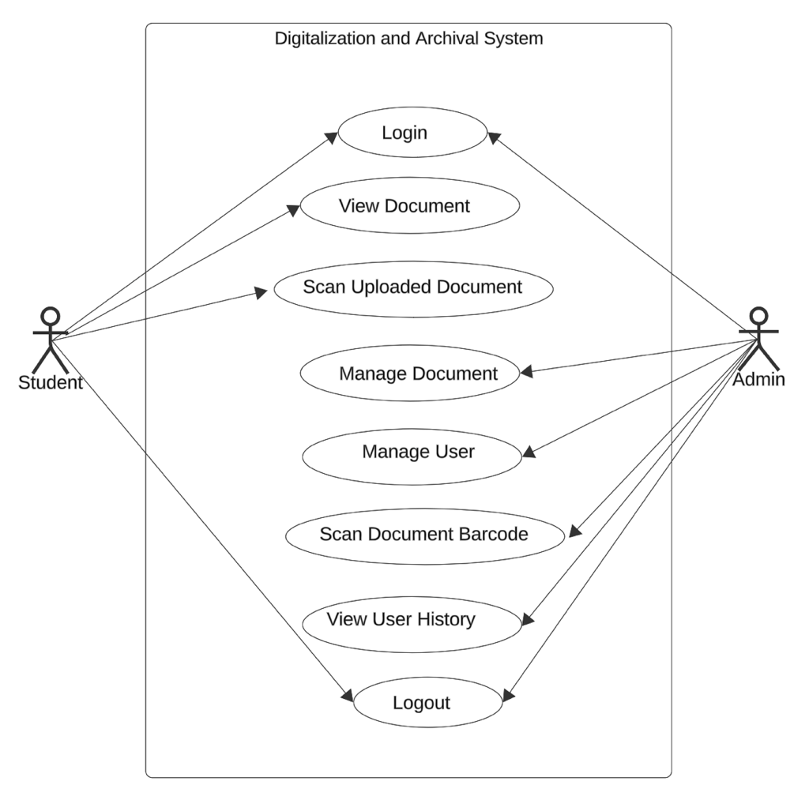

Figure 3.3: Use Case Diagram

Table 3.3: Use-Case Description for Login/Register

|  |  |  |
| --- | --- | --- |
| Use Case: | Login | |
| Description: | This use case describes the process of logging in or registering in the Development of Digitalization and Archival System using Barcode Scanner Application for the Department of Computer Science at Baze University, Abuja. | |
| Actors: | User | |
| Stakeholders: | Baze University Department of Computing and Applied Sciences. | |
| Preconditions: | None | |
| Postconditions: | If logins succeed, user is logged into the system. If login fails system state is unchanged. | |
| Main flow: | User:   1. User selects the login option 2. If the user selects login, the user provides their login credentials. | System:   1. The system validates the provided login details 2. If the validation is successful, the user is logged into the application 3. Use case ends. |
| Exception condition: | Invalid login credentials results in an error message.  User can retry or cancel, ending the use case. | |

Table 3.4: Use case Description for Admin

|  |  |  |
| --- | --- | --- |
| Use case: | Admin | |
| Description: | This use case describes the process digitizing and archiving document with barcode scanner by an administrator in the Development of the Application for the department of Computer Science at Baze university, Abuja. | |
| Actors: | Administrator, System | |
| Stakeholders: | Baze University Department of Computer Science. | |
| Precondition: | Administrator is logged into the application | |
| Postcondition: | The system securely stores the scanned document file successfully in the application. | |
| Main Flow: | Admin:   1. Administrator opens the Digitalization and Archival Application. 2. Administrator selects the “scanned document” option. 3. Administrator enters the document details, such as name, title date, and type. | System:   1. System validates the documents details. 2. If the details are valid, the scanned document file is successfully in the application 3. If the details are invalid, an error message is displayed. |
| Exception condition: | None | |

Table 3.5: Use Case Description for Document upload

|  |  |
| --- | --- |
| Use Case: | Document Upload |
| Description: | This use case describes how administrator uploads a scanned document file in the application. |
| Actors: | System Administrator. |
| Stakeholders: | Baze University Department of Computer Science |
| Precondition: | Administrator is logged into the system. |
| Postcondition: | If uploads succeed, the document is made available for users. If upload fails the documents remains uploaded. |
| Exception Conditions | If the provided document file is invalid, the system displays an error message. |

Table 3.6: Use Case Description for View Document

|  |  |  |
| --- | --- | --- |
| Use Case: | View Document | |
| Description: | This use case describes the process of viewing the scanned document in the application for the Department of Computer Science at Baze University, Abuja. | |
| Actors: | User, System | |
| Stakeholders: | Baze University Department of Computer Science. | |
| Precondition: | User is logged into the Application | |
| Postcondition: | None | |
| Main Flow: | User:   1. User opens the Development of Digitalization and Archival System using Barcode Scanner for Baze University Application 2. User selects the “view document” option. | System:   1. System retrieves the document from the application 2. System displays the documents to the user, including details such as date, time, title, name and type. |
| Exception Condition: | None | |

Table 3.7: Use Case Description for Scanning.

|  |  |  |
| --- | --- | --- |
| Use Case: | Scanning Document | |
| Description: | This use case describes the process of scanning document in the Development of Digitalization and Archival System using Barcode Application for the Department of Computer Science at Baze University. | |
| Actors: | User, System | |
| Stakeholders: | Baze University Department of Computer Science. | |
| Precondition: | User logged into the Application and scanned Document. | |
| Postcondition: | None | |
| Main Flow: | User:   1. User perform and initiates document search 2. User selects a document | System:   1. System delivers scanned documents. |
| Exception Condition: | None | |

Table 3.8: Use Case Description for Deleting

|  |  |
| --- | --- |
| Use Case: | Deleting Document |
| Description: | This use case describes how administrator deletes a scanned document file in the application. |
| Actors: | System Administrator. |
| Stakeholders: | Baze University Department of Computer Science |
| Precondition: | Administrator is logged into the system. |
| Postcondition: | If delete succeed, the document is no longer available for users. If delete fails the documents remains on the system. |
| Exception Conditions | None |

### 3.6.3 Entity Relationship Diagram

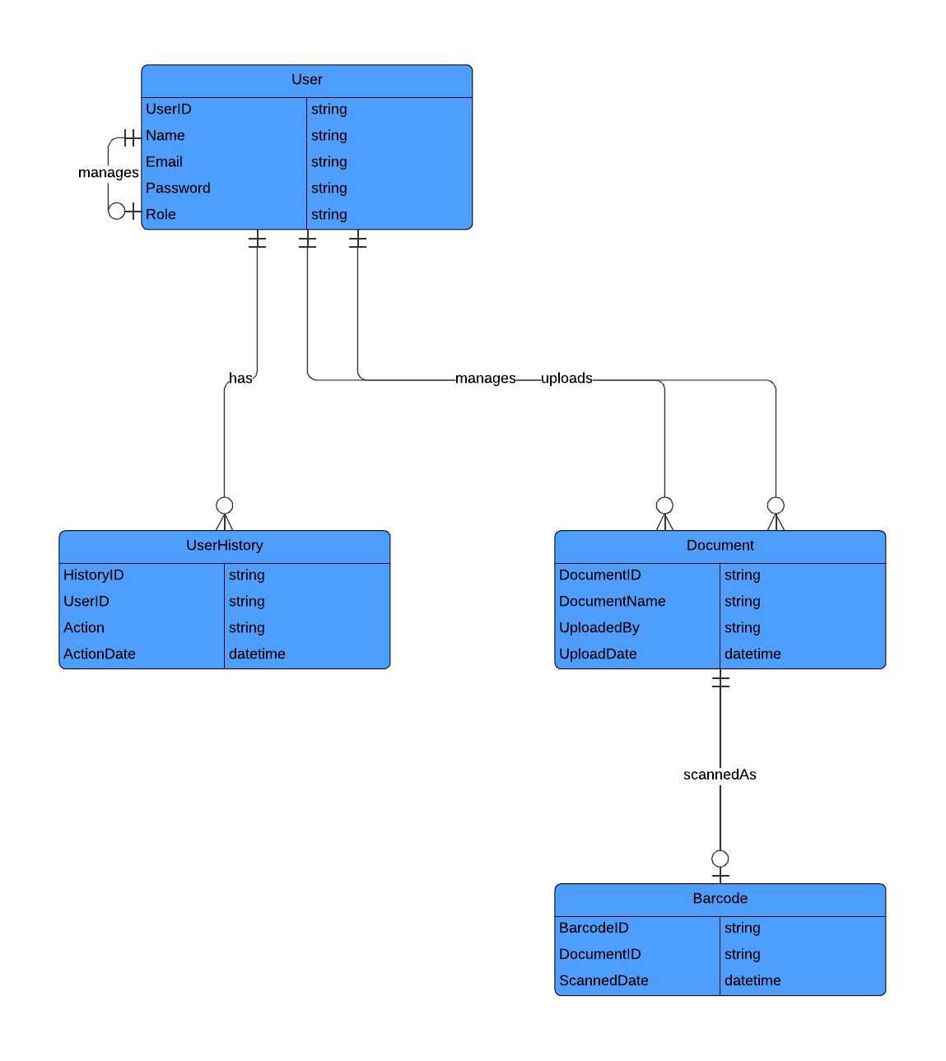

Figure 3.4: Entity Relationship Diagram

### 3.6.4 Activity Diagrams

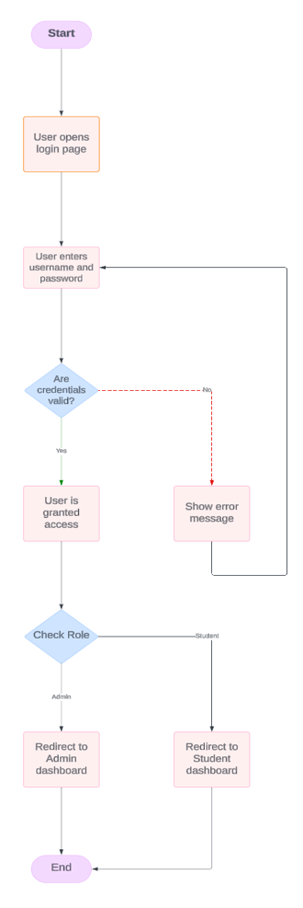

Figure 3.5: Login Activity Diagram



Figure 3.6:Document Upload Activity Diagram (for Student)



Figure 3.7:Manage Document Activity Diagram (for Admin)

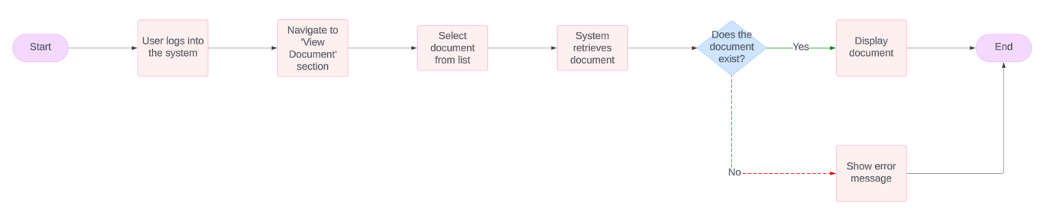

Figure 3.8**:** View Document Activity Diagram (for Student and Admin)

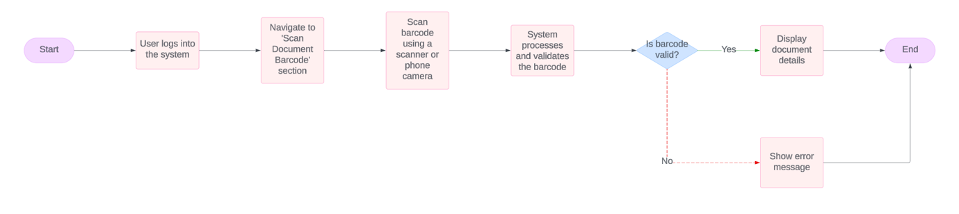

Figure 3.9:Scan Document Barcode Activity Diagram

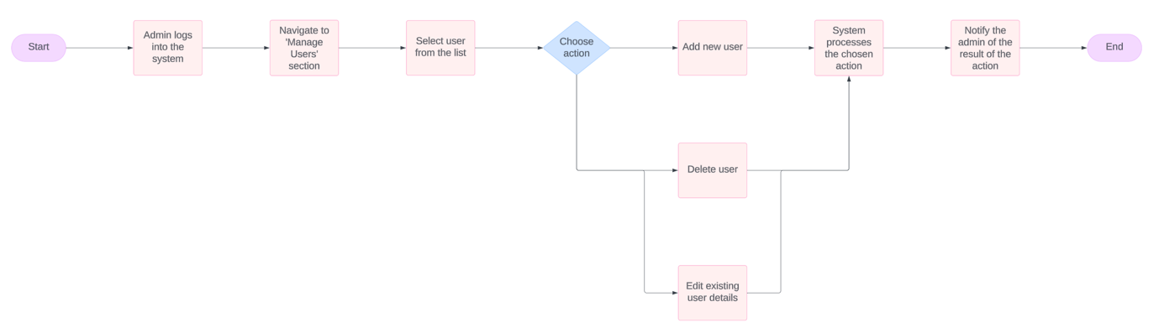

Figure 3.10:Manage User Activity Diagram (for Admin)

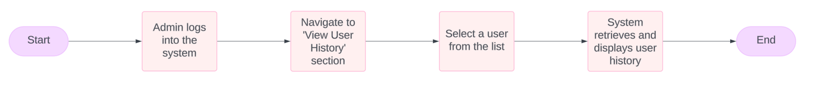

Figure 3.11:View User History Activity Diagram (for Admin)

### 3.6.5 Dataflow Diagram

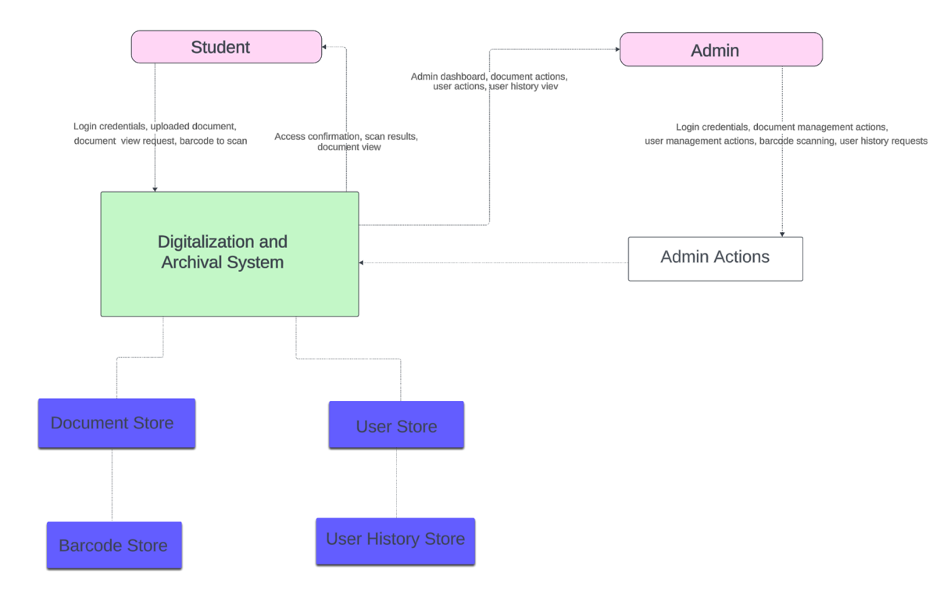

Figure 3.11: Dataflow Diagram

### 3.6.6 Control Flow Diagram

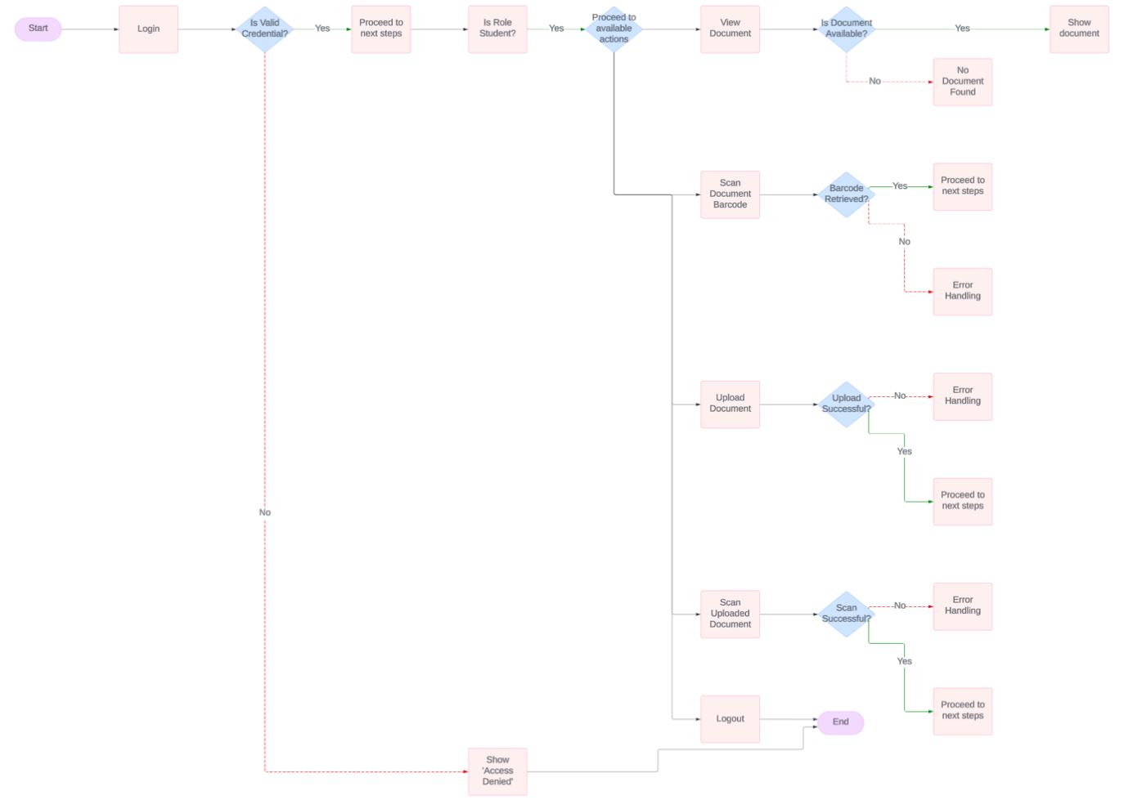

Figure 3.12:Control Flow for Student

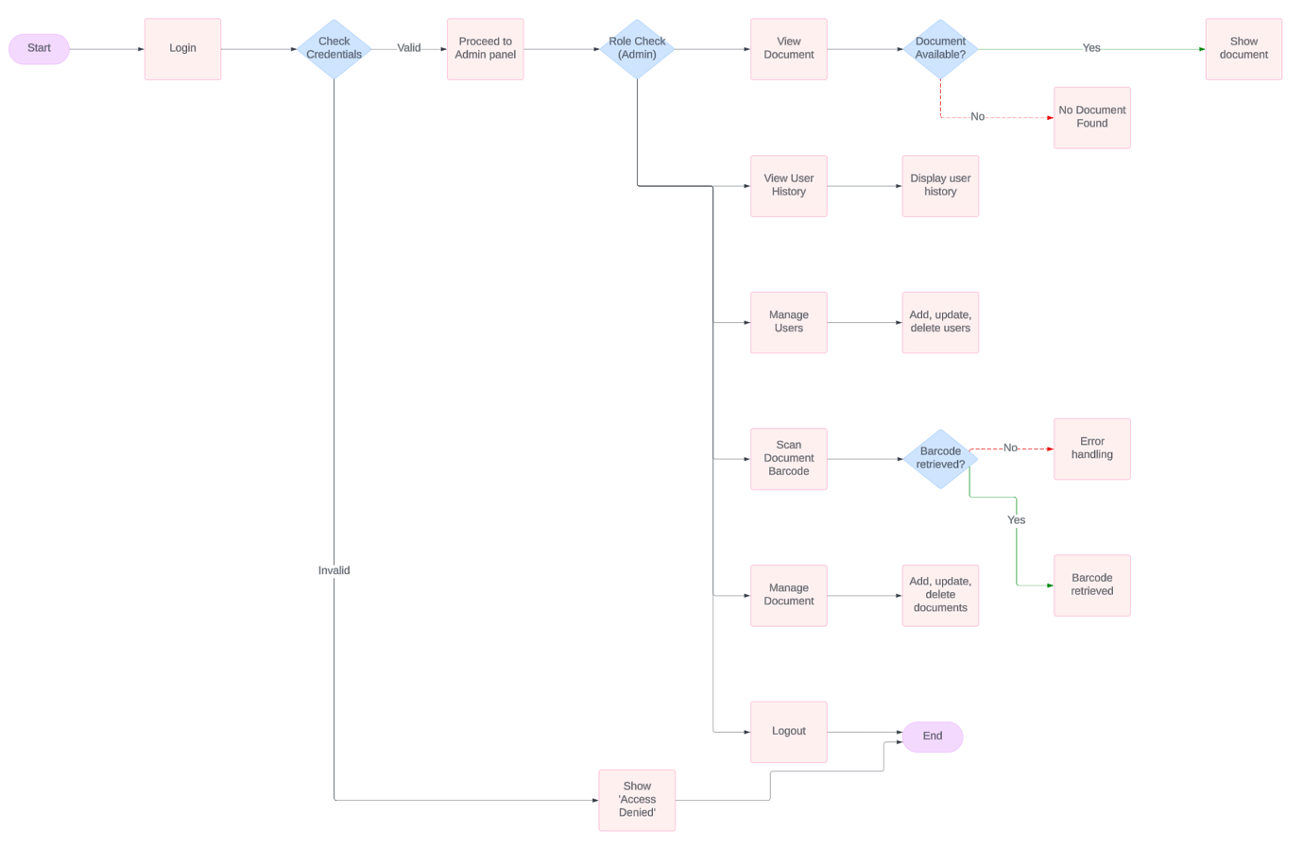

Figure 3.13:Control Flow for Admin

### 3.6.7 User Interface Design Prototype

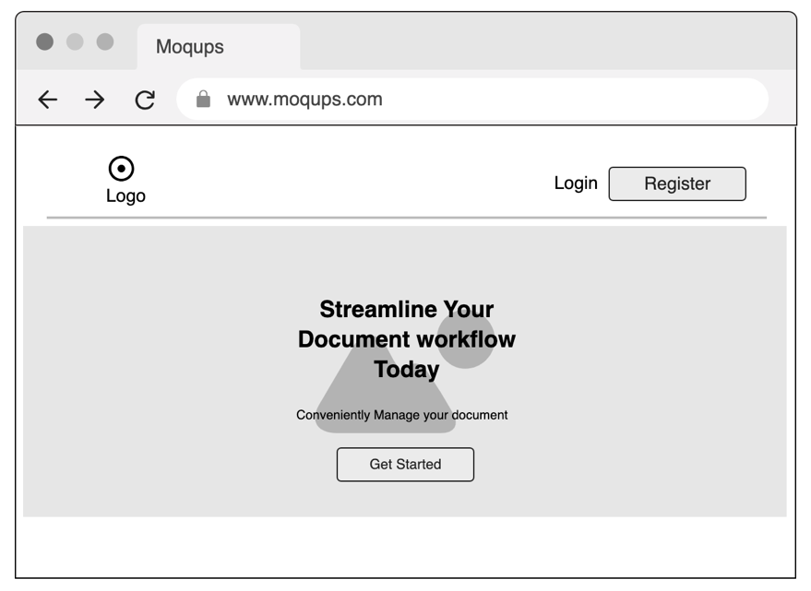

Figure 3.14:Home Page Prototype

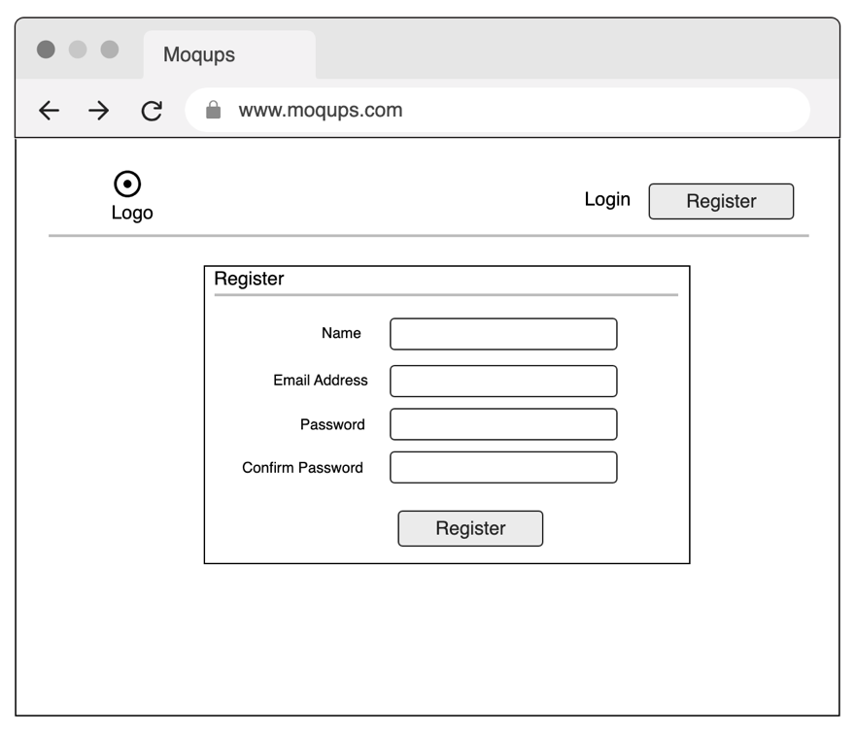

Figure 3.15:Register Page Prototype

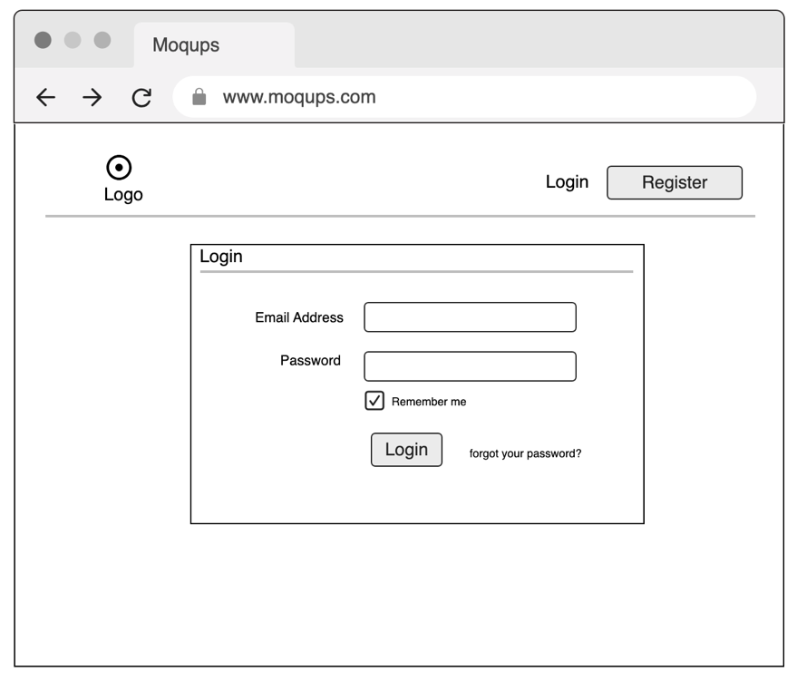

Figure 3.16:Login Page Prototype

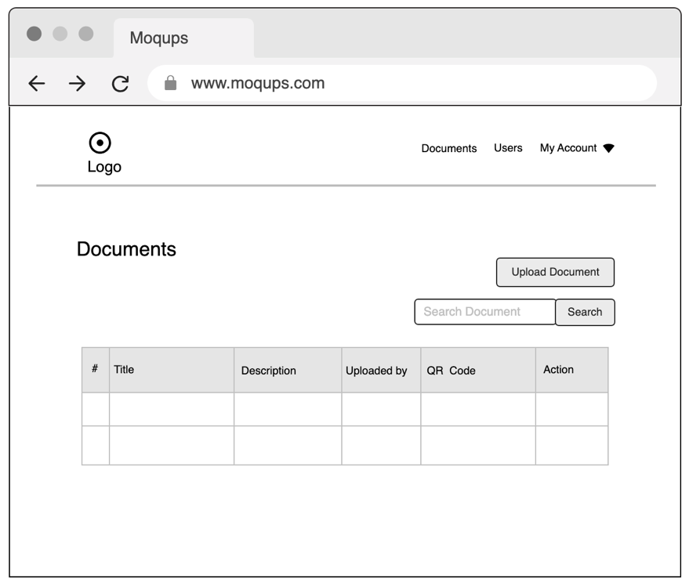

Figure 3.17:Admin View Page Prototype

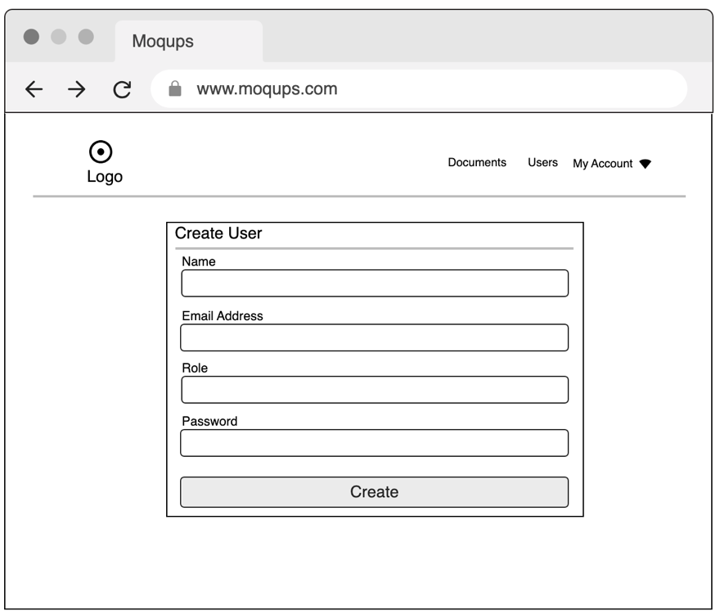

Figure 3.18:Add User Page Prototype

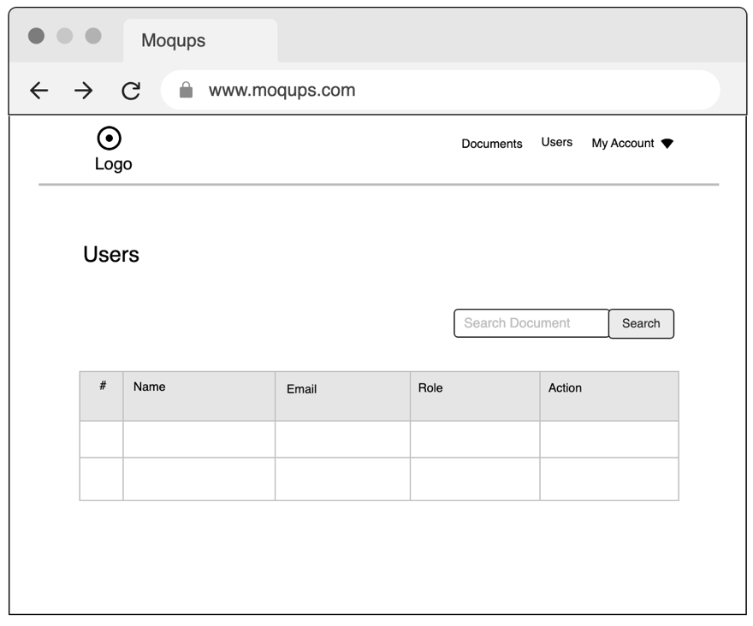

Figure 3.19:View Student Page Prototype

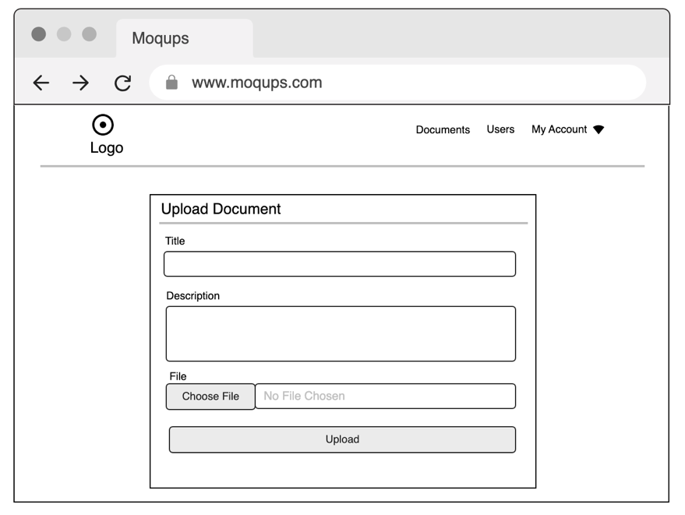

Figure 3.20:Upload Document Page Prototype

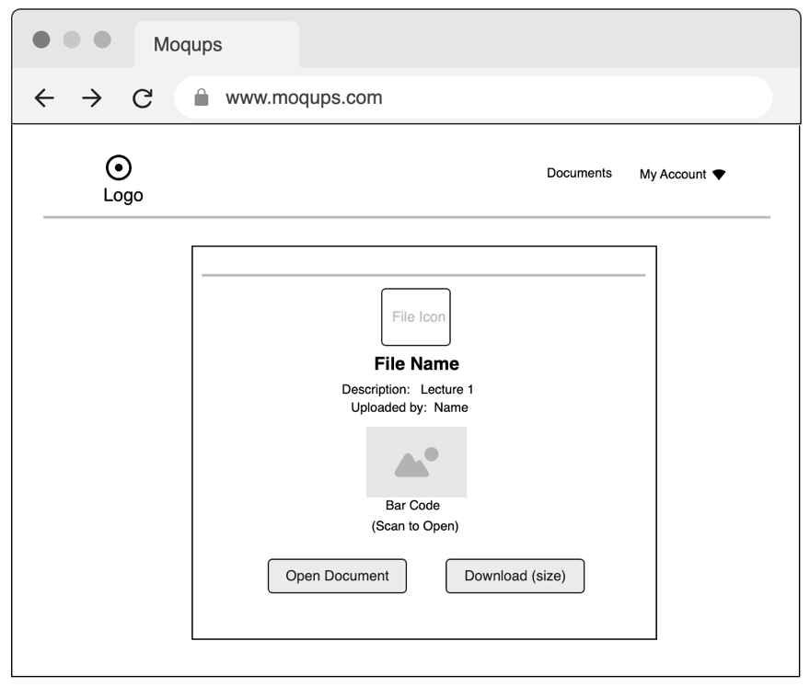

Figure 3.21:Scan Document Page Prototype

## 3.7 Summary

This chapter provides an in-depth requirements, analysis, and design of the system. It starts with an overview and a description of the methodology adopted for the project. The chapter outlines the tools and techniques used and presents a thorough requirement analysis, specifying both software and hardware needs. It then covers the system's requirements, including functional and non-functional specifications. The system design section explores various models, such as the application architecture, use case diagram, entity relationship diagram, activity diagrams, data flow, and control flow diagrams. Lastly, it provides a prototype of the user interface design.

# CHAPTER FOUR

# IMPLEMENTATION AND TESTING

## 4.1 Overview

This chapter outlines the implementation process of the digitalization and archival system using barcode Scanner at Baze University, Abuja. It covers the main features of the application, the problems encountered during implementation, the strategies employed to overcome those problems, and the testing procedures carried out to ensure the applications functionality and reliability.

## 4.2 Main Features

The Development Digitalization and Archival System using Barcode Scanner Application is designed to streamline the process of organizing and managing documents. The application offers a range of features that cater to the needs of various stakeholders, including administrators, and students. The main features of the application are as follows:

1. **User Registration and Login:** The application includes a secure user authentication and authorization system, allowing users to register and log in based on their roles (administrator, student). They can log in using their registered credentials.
2. **Barcode Scanning:** The application helps captures each item (document) as it is assigned a unique barcode for scanning to save time. The application ensures that there are no conflicts in the digitalization process.
3. **Digitalization Workflow Management:** Administrators have the ability to view, edit, add users, upload documents as needed.
4. **User view:** Users can view documents uploaded by administrators allowing them to do their activities effectively.
5. **Reporting and Analytics:** Administrators can generate reports and access analytics related to the system performance and user activity.
6. **User Management:** The system provides an interface for the management of user accounts, Administrators can add or remove users, assign roles and permissions, and manage activities.

## 4.3 Implementation Problems

During the implementation phase of the development of Digitalization and Archival System using Barcode Scanner Application, various challenges encountered. Some of the major problems faced include:

1. **System Architecture:** Designing a scalable and efficient system architecture that can handle large volumes of data and future growth can be complex.
2. **Testing and Quality Assurance:** Rigorously testing the system to identify and address bugs and errors is essential but can be time consuming.
3. **User Interface Design**: it was a significant challenge to create an interface that was user-friendly and met the needs of diverse groups (administrators and students) which entailed extensive user testing and iterative development.
4. **Technical Challenges:** There were technical challenges during the implementation of the system. Some of these challenges include network connectivity issues, hardware failures, and software bugs.
5. **Time constraints:** The project Had a tight timeline, which put pressure on the development team to deliver the system within a limited timeframe. This posed a challenge during the implementation phase, as some features had to be omitted due to time constraints.

## 4.4 Overcoming Implementation Problems

To overcome the implementation problems encountered during the development of the Design and Implementation of Digitalization and Archival System using Barcode Scanner above, various strategies and techniques were employed:

1. **System Architecture:** choose a scalable and flexible system architecture that can accommodate future growth and changes.
2. **Testing and Quality Assurance:** Conduct rigorous testing throughout the development and implementation phases to identify and address problems early on.
3. **User interface design:** An iterative user-centered design approach was adopted, involving extensive user testing. This helped refine user interface and ensure a consistent and intuitive experience across different user roles and devices.
4. **Technical Challenges:** Keep the system up-to-date with the latest technical technologies, and also select hardware components that are compatible with the software and meet the system’s requirements.

Through these measures, the implementation problems encountered during the development of the Design and Implementation of Digitalization and Archival System using Barcode Scanning for Baze University were effectively addressed, ensuring the successful implementation and use of the system.

## 4.5 Testing

The testing phase is an essential part of software development that ensures the quality of the system. To ensure the reliability and functionality of the Application, a comprehensive testing strategy was employed. The testing process involved the following phases:

Table 4.1: Testing for Add User

|  |  |
| --- | --- |
| Test case | Add User |
| Related Page | Admin Dashboard |
| Test Procedure | 1. Navigate to “Add User” page 2. Enter the required details 3. Click on the “Add” button |
| Test Data | User Details |
| Expected results | User Added successfully |
| Actual results | User Added successfully |
| Status | Pass |
| Remarks | none |
| Created By | Aisha Dahiru Shettima |
| Date of creation | 24th August, 2024 |
| Executed by | Aisha Dahiru Shettima |
| Date of Execution | 24th August, 2024 |
| Test Environment | DELL Computer |

Table 4.2: Testing for View Users

|  |  |
| --- | --- |
| Test Case | View User |
| Related Page | Admin Dashboard |
| Test Procedure | 1. Navigate to “View Users” page 2. Retrieve the list of users. |
| Test Data | None |
| Expected Result | List of users displayed |
| Actual Result | List of users displayed |
| Status | Pass |
| Remark | None |
| Created By | Aisha Dahiru Shettima |
| Date of execution | 24th August, 2024 |
| Executed By | Aisha Dahiru Shettima |
| Date of Execution | 24th August, 2024 |
| Test Environment | DELL Computer |

Table 4.3: Testing for Upload Documents

|  |  |
| --- | --- |
| Test Case | Upload Documents |
| Related Page | Admin Dashboard |
| Test Procedure | 1. Navigate to the “upload document” button 2. Choose the document file to upload 3. Click on the “upload” button. |
| Test Data | Document upload |
| Expected Result | Admin is able to upload the document successfully |
| Actual Result | Admin successfully uploaded the document. |
| Status | Pass |
| Remark | None |
| Created By | Aisha Dahiru Shettima |
| Date of Creation | 24th August, 2024 |
| Executed By | Aisha Dahiru Shettima |
| Date of Execution | 24th August, 2024 |
| Test Environment | DELL Computer |

Table 4.4: Testing for View Document

|  |  |
| --- | --- |
| Test Case | View Documents |
| Related Page | Admin Dashboard |
| Test Procedure | 1. Navigate to “view document” page 2. Retrieve the document |
| Test Data | None |
| Expected Result | Documents Displayed |
| Actual Result | Documents Displayed |
| Status | Pass |
| Remark | None |
| Created By | Aisha Dahiru Shettima |
| Date of Creation | 24th August, 2024 |
| Executed By | Aisha Dahiru Shettima |
| Date of Execution | 24th August, 2024 |
| Test Environment | DELL Computer |

Table 4.5: Testing for Document Scanning

|  |  |
| --- | --- |
| Test Case | Document Scanning |
| Related Page | Admin Dashboard |
| Test Procedures | 1. Navigate to the “scanning” page 2. Scanned the desired documents 3. Document Displayed |
| Test Data | Scanned Document |
| Expected Result | Document Displayed Successfully |
| Actual Result | Document Displayed Successfully |
| Status | Pass |
| Remark | None |
| Created By | Aisha Dahiru Shettima |
| Date of Creation | 24th August,2024 |
| Executed By | Aisha Dahiru Shetima |
| Date of Execution | 24th August, 2024 |
| Test Environment | DELL Computer |

Table 4.6: Testing for Login Page (Students)

|  |  |
| --- | --- |
| Test Case | Login Page |
| Related page | Login Page |
| Test Procedures | 1. Navigate to the login page 2. Enter valid username and password 3. Click on the “Login” button |
| Test Data | Valid username and password |
| Expected Result | Student logged in successfully |
| Actual Result | Student logged in successfully |
| Status | Pass |
| Remark | None |
| Created By | Aisha Dahiru Shettima |
| Date of Creation | 24th August, 2024 |
| Executed By | Aisha Dahiru Shettima |
| Date of Execution | 24th August, 2024 |
| Test Environment | DELL Computer |

Table 4.7: Testing for Register Page (Student)

|  |  |
| --- | --- |
| Test Case | Register |
| Related Page | Register page |
| Test Procedure | 1. Navigate to the register page 2. Enter the required details 3. Click on the “Register” button |
| Test Data | Student details |
| Expected Result | Student registered successfully |
| Actual Result | Student registered Successfully |
| Status | Pass |
| Remark | None |
| Created By | Aisha Dahiru Shettima |
| Date of Creation | 24th August, 2024 |
| Executed By | Aisha Dahiru Shettima |
| Date of Execution | 24th August, 2024 |
| Test Environment | DELL Computer |

Table 4.8: Testing for Logout

|  |  |
| --- | --- |
| Test Case | Logout |
| Related Page | Admin Dashboard/User Dashboard |
| Test Procedure | Click on the “Logout” button |
| Test Data | None |
| Expected Result | User logged out successfully |
| Actual Result | User logged out successfully |
| Status | Pass |
| Remark | None |
| Created By | Aisha Dahiru Shettima |
| Date of Creation | 24th August, 2024 |
| Executed By | Aisha Dahiru Shettima |
| Date of Execution | 24th August,2024 |
| Test Environment | DELL Computer |

## 4.6 User Guide

This section provides a brief guide on how to use Digitalization and Archival System Application:

1. User Registration and Login

* Open the application in a web browser.
* If you are a new user, click on the “Register” button and provide the required information to create an account.
* If you already have an account, click on the “Login” button and enter your credentials.

1. Administrators

* After logging in, administrators will have access to administrative functions
* View and manage user accounts
* Perform administrative tasks, such as creating users, uploading documents, and managing resources.

1. Student (user)

* After logging in, students can view uploaded documents.

## 4.7 User Interface Design

The user interface (UI) design of the Application plays a crucial role in ensuring a seamless and intuitive experience for users. The UI design process followed a user-centered approach, incorporating feedback and usability testing to create an accessible and visually appealing interface. The key aspects of the UI include:

#### 

Figure 4.1: Home page

The “Home page” represents the welcome page for all users. From here they can login or register and then navigate through the system.

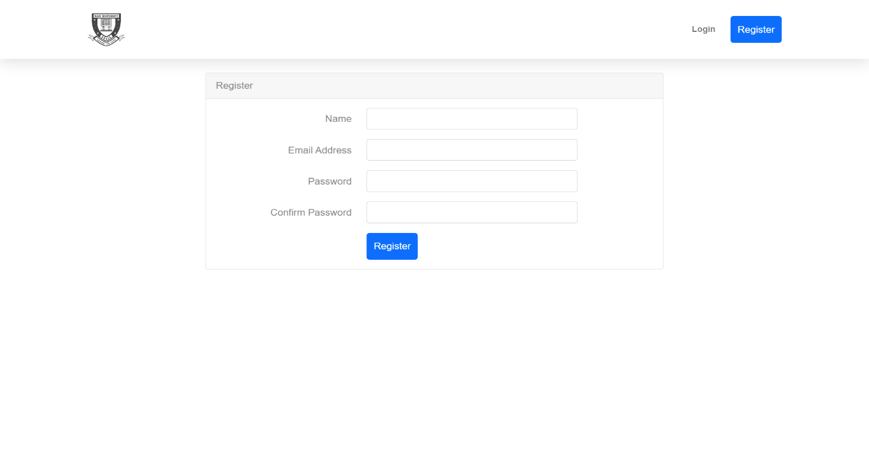

Figure 4.2: Register Page

The “Register page” represents the registration process for new users, such as students or administrators. It usually involves filling out a registration form with required details like name, email, password and other relevant information.

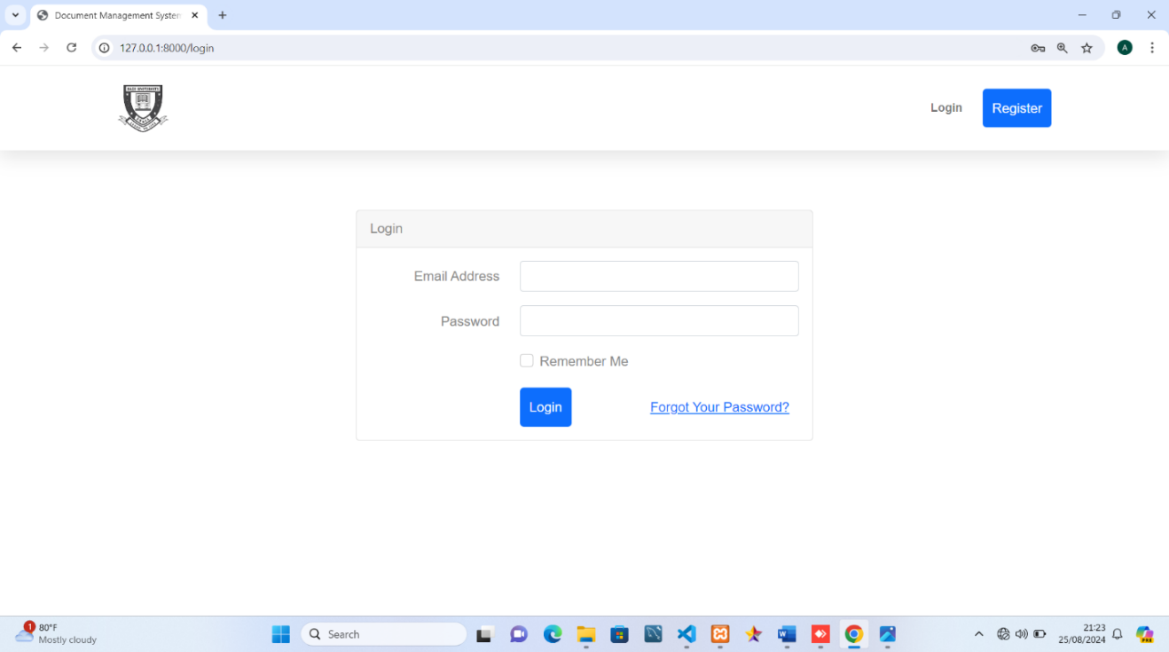

Figure 4.3: Login page

The “Login” page shows the login interface for registered users to access their personal accounts within the Application. Users typically provide their registered email and passwords to authenticate and gain access to their respective accounts.

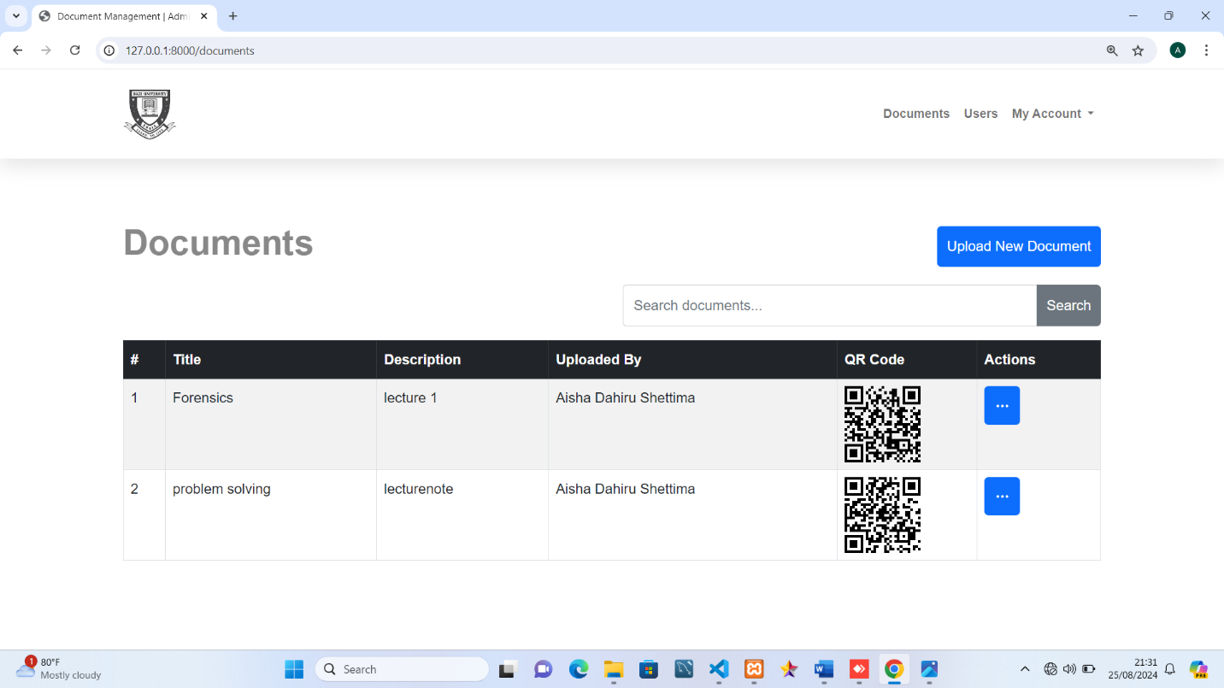

Figure 4.4: View Admin Page

The “View Admin” page provides a comprehensive list of all the documents uploaded in the system. It displays relevant information about each documents including their title, description, QR code and other details. This page enables administrators to efficiently manage users by allowing them to view, edit, or delete document information.

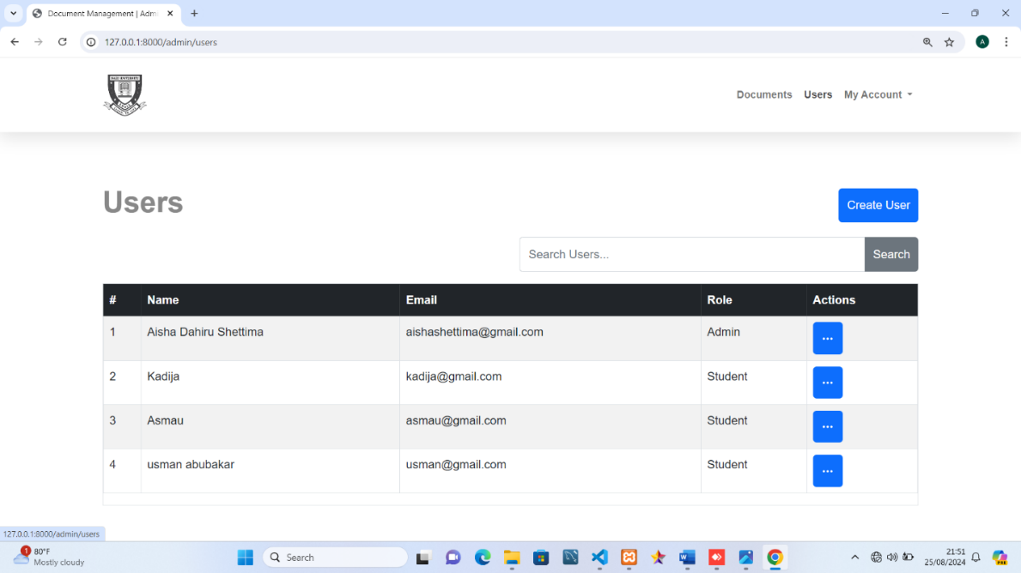

Figure 4.5: View Student Page

The “View User” page presents lists of all registered users in the system. This page help administrators oversee user’s records and enables them to perform various activities such as viewing, editing, or deleting information. It showcases information such as their name, student email, and other relevant details.

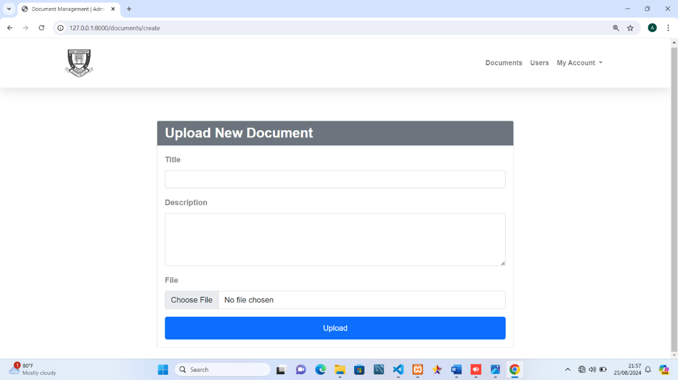

Figure 4.6: Upload Documents Page

The “upload document” page where administrators can upload documents. It provides student with easy access to the document.

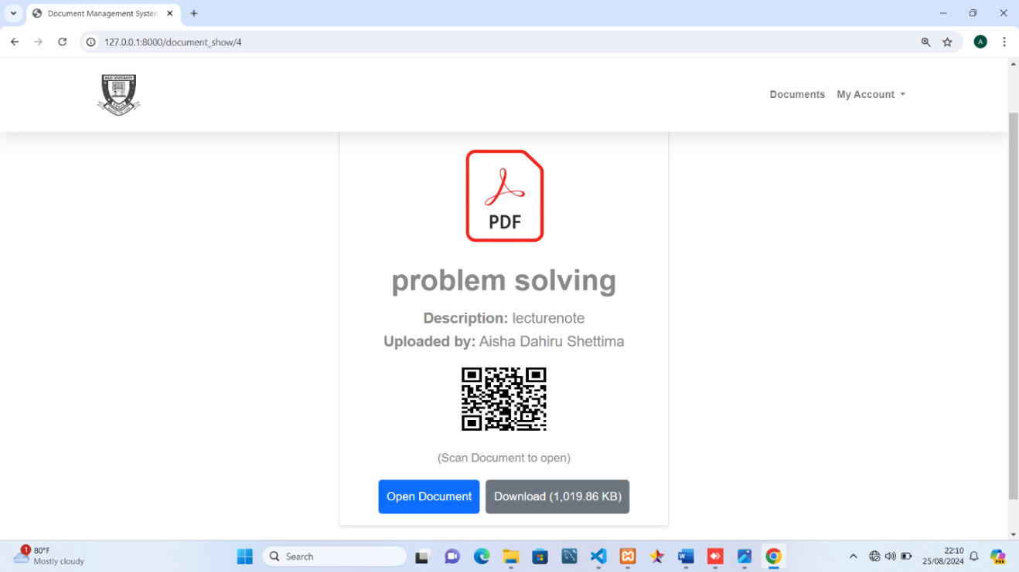

Figure 4.7: Scan document page

This page allows users to have access to scan the uploaded documents.

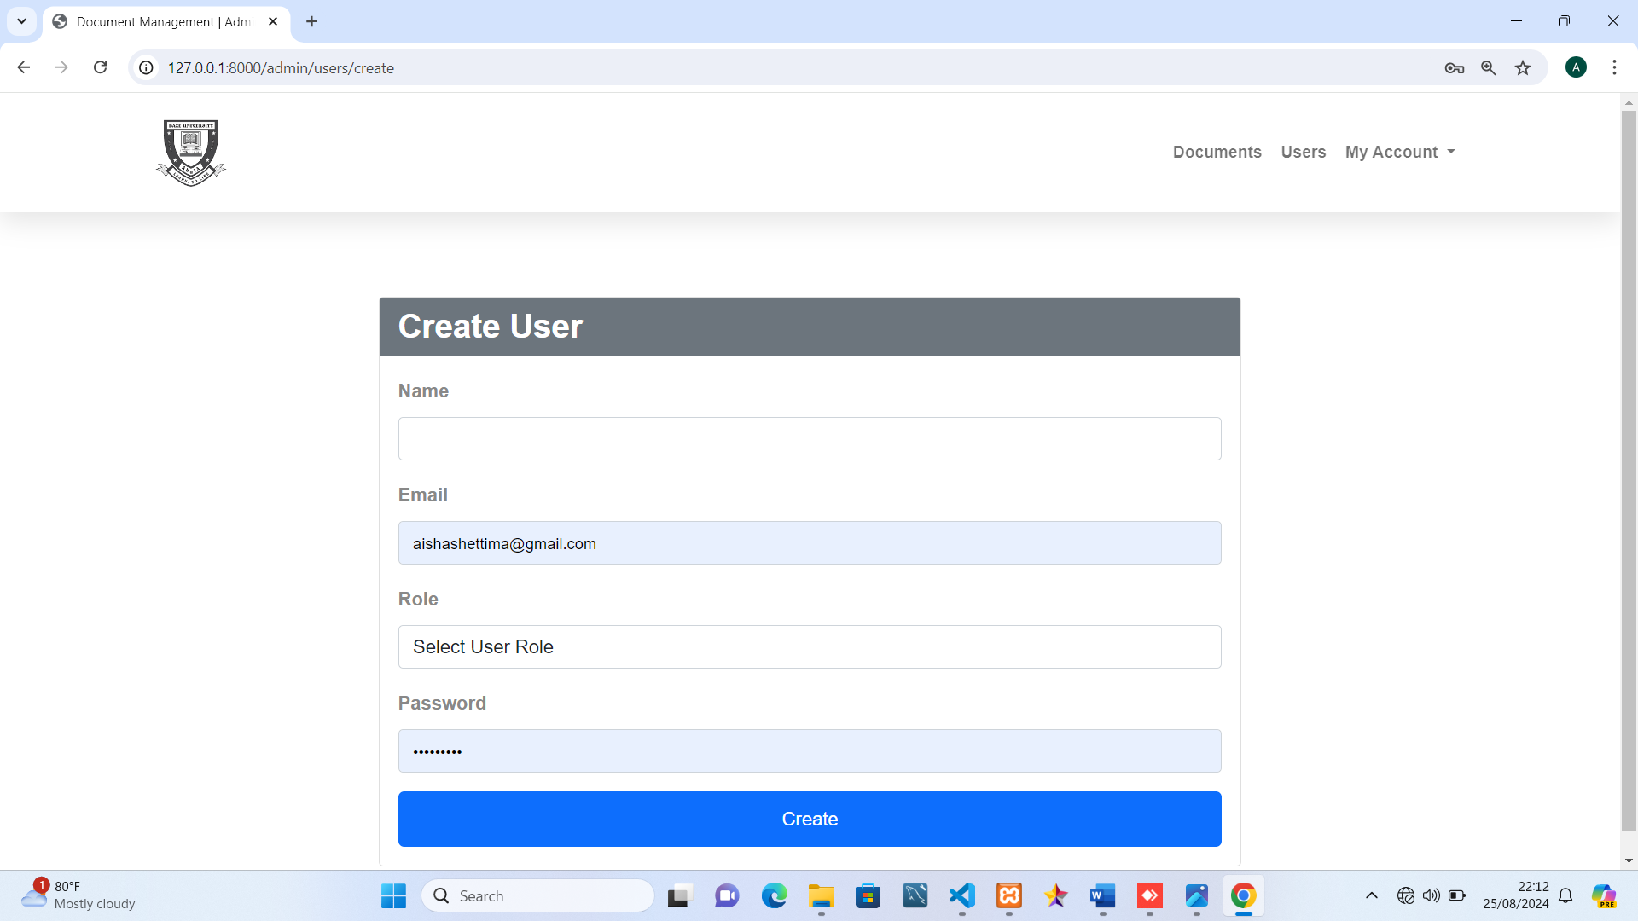

Figure 4.8: Add User Page

This “Add User” is page designed for administrators to add new user to the system. It presents a form with fields to be filled by the administrator.

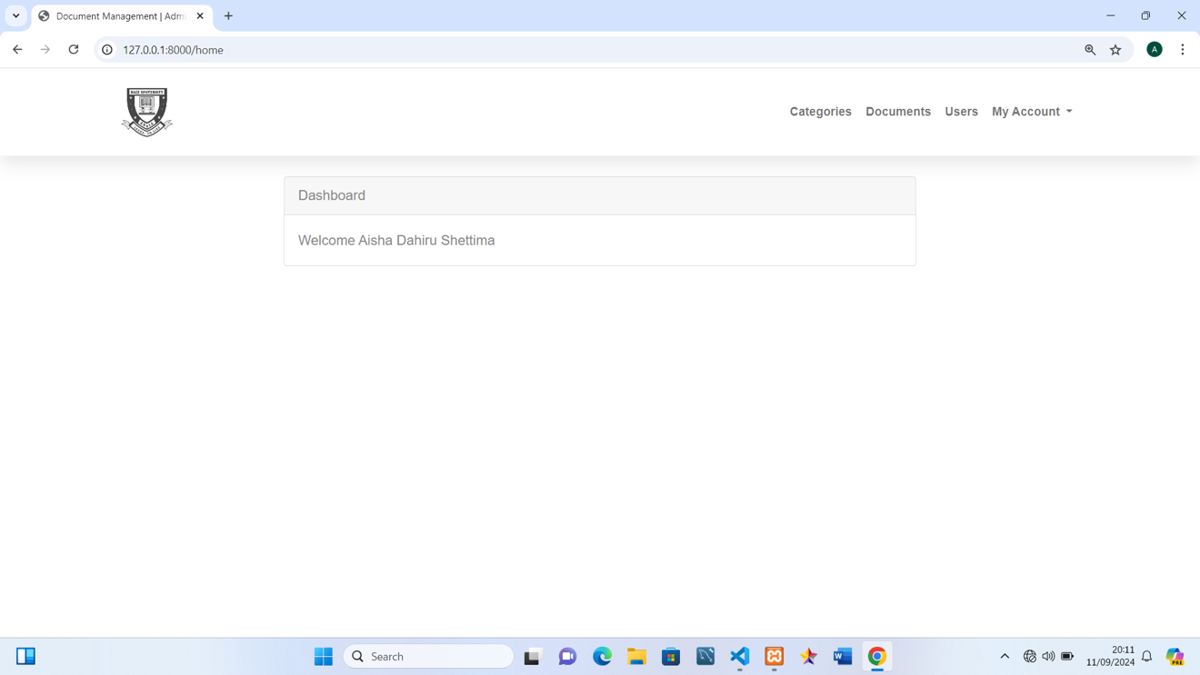

Figure 4.9: User Dashboard Page

This “User Dashboard” is user-specific page, from which each user can navigate and perform actions on the system.

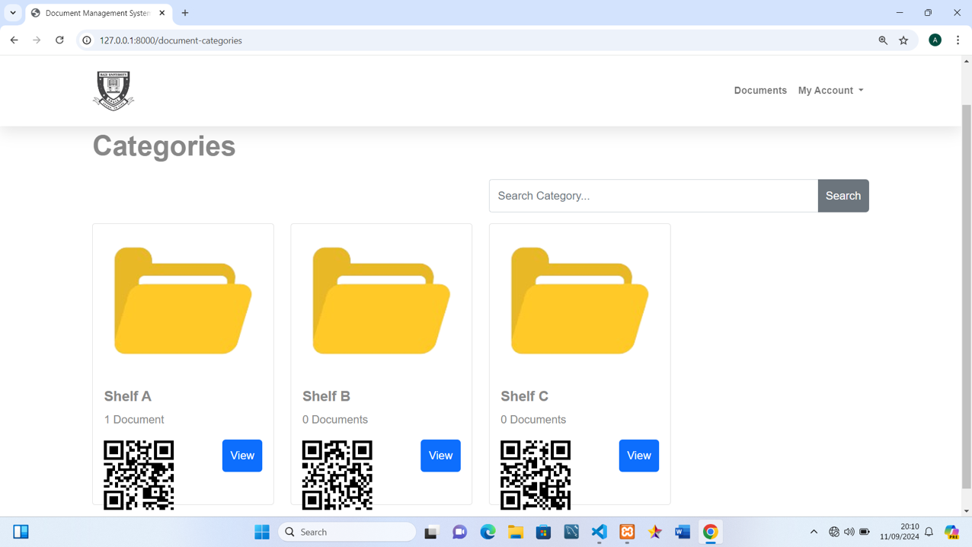

Figure 4.10: Category View Page

This page presents the categories already available on the system from which each user can select.

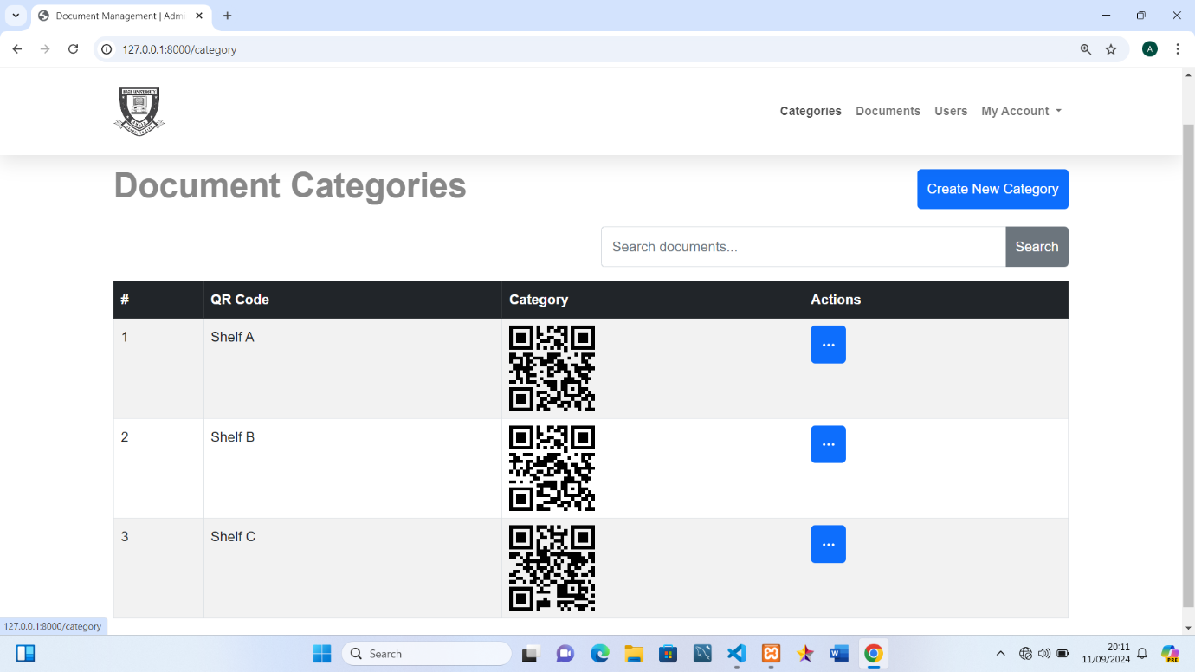

Figure 4.11: Category Action Page

This page shows the categories already available on the system, it also allows users to navigate and perform actions including adding a category.

## 4.8 Summary

The implementation of the Digitalization and Archival System using Barcode Scanner for Baze University was successful and met all the requirements. The user guide was created to assist users in understanding and using the system effectively. During implementation, some challenges were encountered, such as data migration issues, network connectivity problems, and user acceptance testing delays.

# CHAPTER FIVE

# DISCUSSION, CONCLUSION, AND RECOMMENDATIONS

## 5.1 Overview

This chapter provides a comprehensive discussion on Digitalization and archival system using barcode scanner for Baze University. It evaluates the extent to which the project objectives have been achieved, highlights the limitations and challenges encountered during the development process, and suggests potential future enhancement. Additionally, recommendations are provided to ensure the effective implementation and adoption of the application within the university community.

## 5.2 Objectives Assessment

The Development of Digitalization and Archival System using Barcode Scanner for Baze University Application was to develop a system that is easy to use, automated, and efficient for document scanning.   
Chapter One provided the following objectives:

1. To scan physical documents to create digitized documents.
2. To create respective QR code for efficient searching, sorting, and indexing.
3. To implement appropriate user access control.
4. To Implement measures to protect digital archives from unauthorized access, ensuring the confidentiality and integrity of sensitive information

The Application primary objective, which was to provide an automated and user-friendly document storage at Baze University, has successfully been achieved through assessment.

## 5.3 Limitations and challenges

The Application’s implementation was successful, but there were several limitation and challenges encountered during the development process:

1. **Hardware and Software Compatibility:** Ensuring compatibility between barcode scanners, digital storage devices, and archival software can be a complex task. Outdated or incompatible systems can hinder efficiency and data integrity.
2. **Scalability Considerations:** As the number of users increases, ensuring the application’s scalability and performance becomes a critical concern
3. **Data Privacy and Security:** Protecting sensitive data stored in digital archives is crucial, inadequate security measures can expose to data breaches, compromising privacy and reputation.
4. **Time constraints:** The application was developed within a limited time. These constraints may have restricted the ability to add additional features or enhancements, even though the primary objectives were achieved.
5. **User Training and Adoption:** Educating on how to use the digital archival system was crucial for its successful implementation.

## 5.4 Future Enhancements

To further optimize the digital archival system at Baze University, the following enhancement could be considered:

1. **Cloud Integration:** If this system is integrated with cloud storage systems such as Google drive, users will have the ability to access their documents from anywhere. As well as providing enhanced storage capacity and enabling automatic backup.
2. **Mobile Application:** Mobile apps for Android and iOS platforms can be developed in order to enhance user experience. This because an app will provide flexibility and seamless accessibility to the users on the go. Users can perform all actions from their mobile devices which enhances convenience.
3. **Version Control for Documents:** Version control features can be added in the future in order to allow multiple users to keep several versions of the same document. This feature will allow users to track changes and revert to previous versions when necessary.
4. **User Feedback and Help Desk Integration:** The integration of feedback system in which user can report issues and make suggestions for improvements will significantly enhance their experience.
5. **Integration with Other Institutional Systems:** In order to bring about user-friendly and seamless access to related documents and data, the system can in the future be integrated with other existing institutional platforms. These platforms may include Learning Management Systems (LMS) or Student Information Systems (SIS)

# REFERENCES

Besser, H. (2007). Digital Preservation of Photographs: Preparing for the 21st Century. Getty Conservation Institute.

Carillo, K., et al. (2020). Barcode Technology: Past, Present, and Future. International Journal of Information Management, 50, 256-265.

Cox, R. J. (2011). Digital Archives Management: Access, Use and Preservation. Chandos Publishing.

Lanza, M., et al. (2019). Challenges and Solutions in the Management of Barcode Data. Journal of the Association for Information Science and Technology, 70(5), 505-514.

Marshall, C. C. (2009). New Applications for Digital Libraries: The Use of Barcode Technology to Link Physical Objects with Electronic Documents. Proceedings of the 9th ACM/IEEE-CS Joint Conference on Digital Libraries, 369-372.

Patterson, E. S., et al. (2006). The Role of Bar Coding and Smart Pumps in Safety in Medication Administration. Joint Commission Journal on Quality and Patient Safety, 32(3), 144-152.

Pugh, M. J., & Imperiale, N. (1997). Barcode Technology in Libraries: Its Use and Implications. Library Hi Tech, 15(1/2), 7-24.

PNG Tree. (2024). https://pngtree.com

Smith, R., & Martinez, L. (2018). A History of the Barcode. New York University Press. • Kesan, J. P., & Shah, R. C. (2001). A Brief History of Barcodes. IEEE Micro, 21(1), 8-18.

Williams, C., & Sawyer, E. J. (2006). Implementing a Barcode Scanning System for Archival Finding Aids. Journal of Archival Organization, 4(3-4), 177-193.

Young, M. A. (2014). The Impact of Barcoding on Library Technical Services. Library Resources & Technical Services, 58(1), 35-46.

# APPENDICES

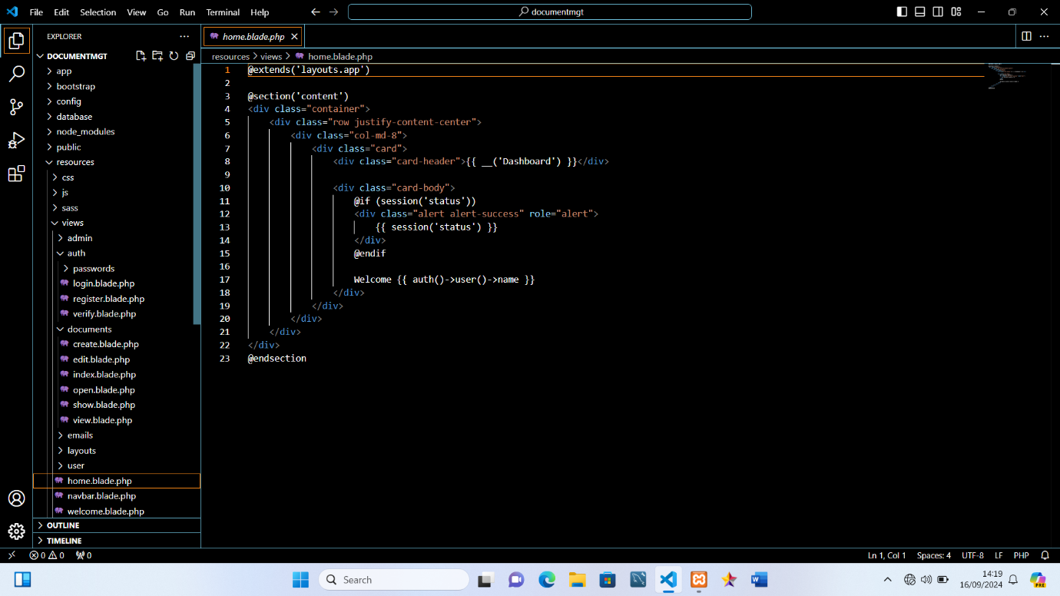

Appendix A

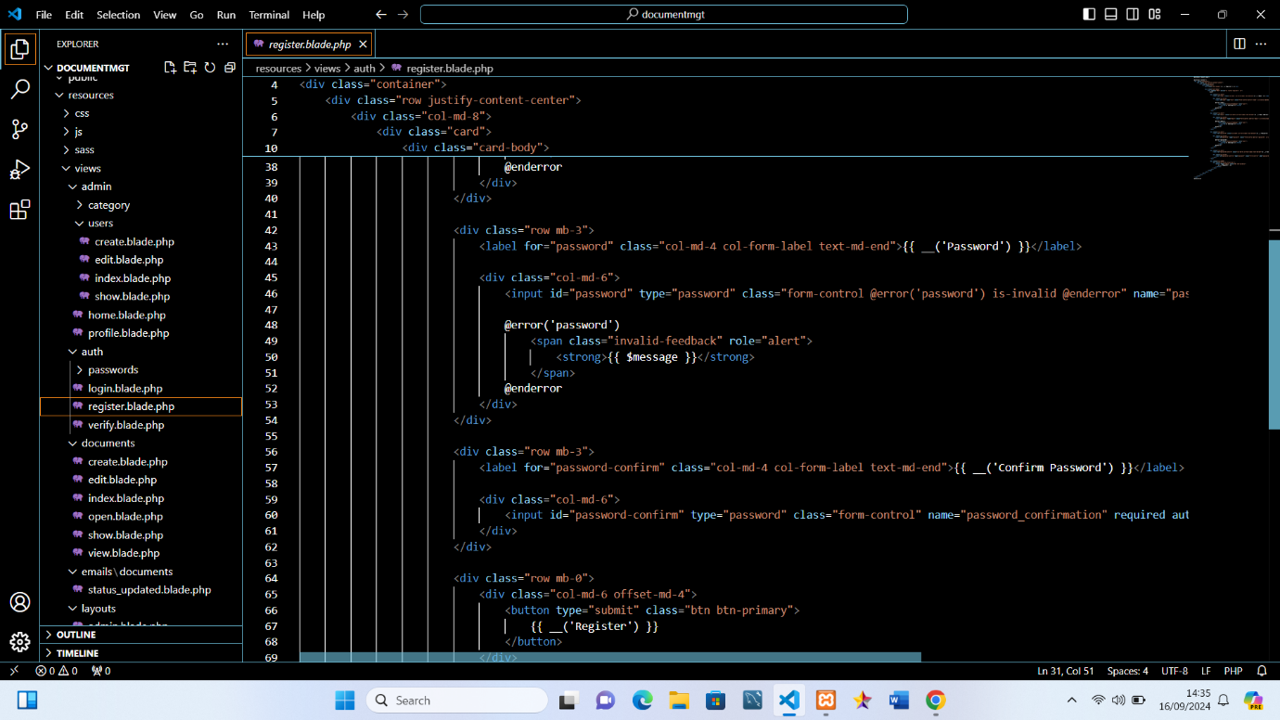

Appendix B

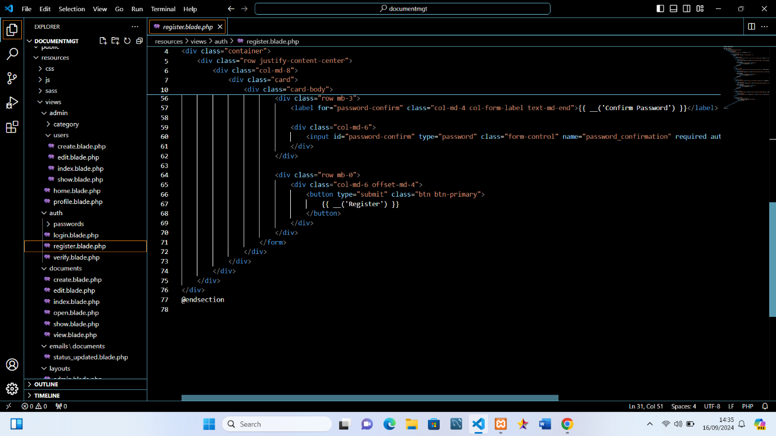

Appendix C

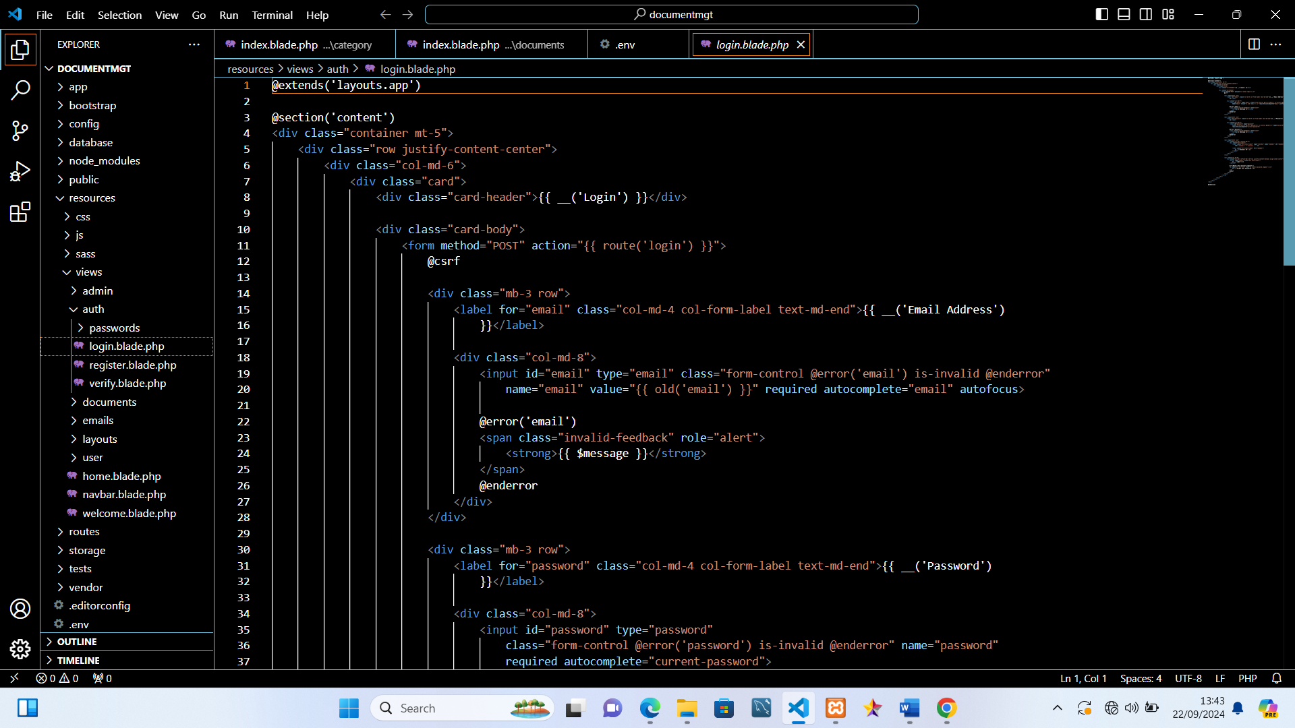

Appendix D

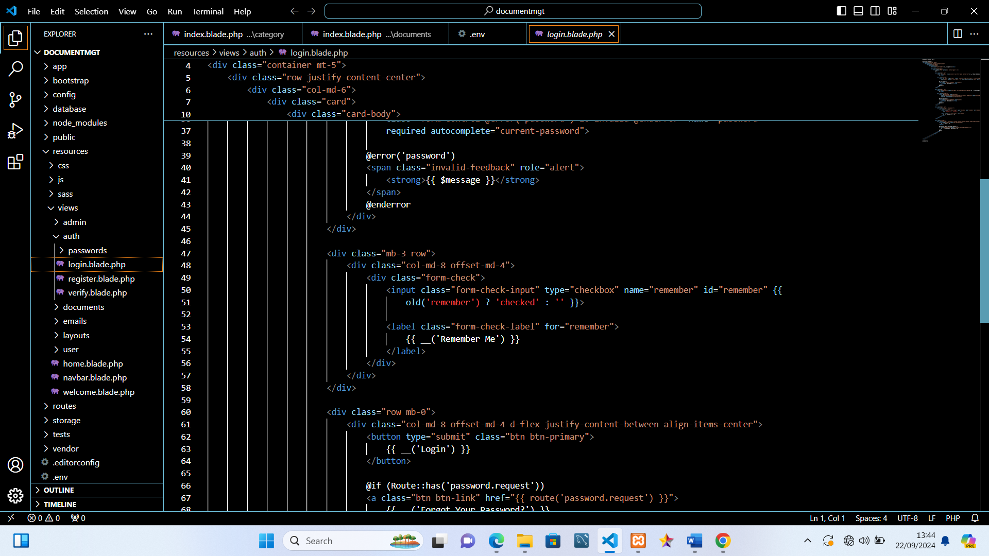

Appendix E

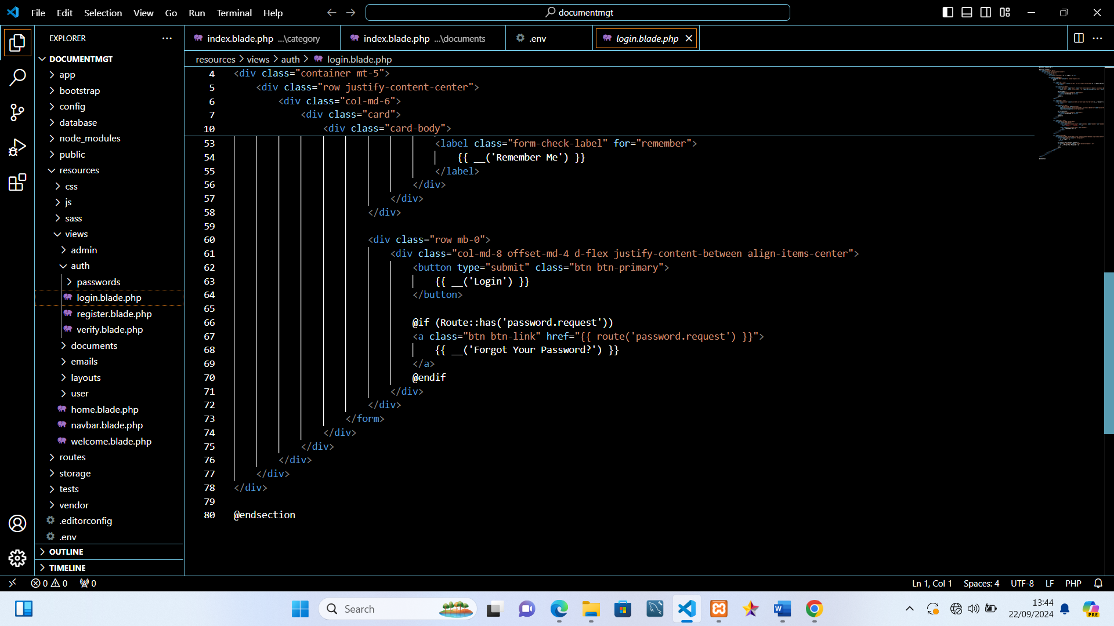

Appendix F